Bowers & Wilkins expands its relationship with McLaren Automotive
and the McLaren Formula 1 Team with the new Px8 S2 McLaren Edition
Press Release
- A uniquely designed edition of the award-winning Bowers & Wilkins Px8 S2 wireless headphones featuring McLaren-inspired styling, representing a further celebration of the decade-long partnership between the brands.
- All-new bespoke, ultra-high-resolution Carbon Cones – angled within each earcup – deliver lower distortion and better resolution for reference-quality audio.
- New bespoke finish features luxurious materials and includes diecast aluminium arms, diamond-cut bright metal detailing and Nappa leather trim, combined with McLaren-inspired colours and branding.

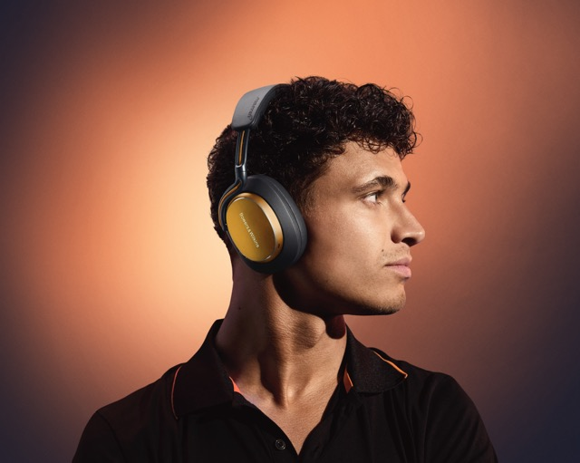
Worthing, UK, 19th November 2025: The Px8 S2 McLaren Edition, a new version of the award-winning Bowers & Wilkins Px8 S2 wireless headphones, has been unveiled.

Developed in collaboration with McLaren Automotive and the McLaren Formula 1 Team, the new headphones build on the success of the acclaimed Px8 S2. The design integrates the signature McLaren Papaya finish together with a striking Anthracite Grey, as well as carefully considered reveals of the McLaren Speedmark on both the headband and earcups.

A diamond-cut bright edge on each elliptical logo plate and memory-foam cushions and headband trimmed in soft, luxurious Nappa leather deliver the ultimate, premium feel.

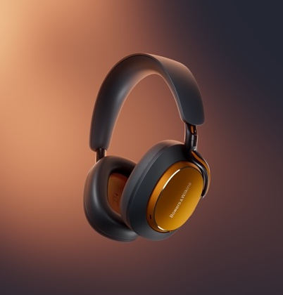

Enthralling sound fused with iconic McLaren design
Reflecting the two brands’ shared technical and performance-led aesthetic, the
Px8 S2 McLaren Edition offers the high-performance sound quality that Bowers & Wilkins is famous for, coupled with a design that connects fans of McLaren cars and the McLaren Formula 1 Team to the visual identity of the McLaren brand. The third headphone in the successful partnership elevates the performance standard still further, offering proprietary Bowers & Wilkins-optimised noise cancellation technology to effectively shut out unwanted noise – crucially, without harming musicality.

In Px8 S2 McLaren Edition, performance is taken to even greater heights of detail, resolution and spaciousness thanks to upgraded bespoke 40mm Carbon Cone drive units. These drive units feature a comprehensively redesigned and improved chassis, voice coil, suspension and magnet, and are carefully angled to the listener’s ears to ensure a consistent distance from every point across the surface of each driver to each ear, ensuring better imaging and stereo spaciousness. The headphone also features Qualcomm’s aptXTM Adaptive 24/96 wireless technology and aptX Lossless plus powerful Bowers & Wilkins-developed DSP (Digital Signal Processing) to deliver outstanding, 24-bit / 96kHz high-resolution sound quality.

As with all other current generations of Bowers & Wilkins headphones and earbuds, the Px8 S2 McLaren Edition can be configured and controlled using the brand’s Music app. You can activate or disengage the noise-cancelling transparency mode to let in more or less of the outside world, monitor the headphone’s charge levels, select the wear sensor sensitivity and define your preferred operation for the physical ‘Quick Action’ button on the headphones. Listeners can now opt to fine-tune the sound through an adjustable five-band EQ, complete with the option to store their preferred settings as easily accessible presets. With a 30-hour battery life, Px8 S2 McLaren Edition can play all day long – and more – on just one charge, while a 15-minute quick recharge is sufficient to provide up to seven hours of additional listening time, so you’ll never be without your favourite music for long.

Following the Pi8 McLaren Edition launch earlier this year, the Px8 S2 McLaren Edition will be available to consumers from 19th November, combining their passion for high performance audio technology and their love for the McLaren Formula 1 Team.

Speaking on behalf of Bowers & Wilkins, Lyle Smith, President of Sound United at HARMAN, said: “This exciting new edition of our exceptional Px8 S2 headphones perfectly celebrates our long-term partnership with McLaren, and gives fans another industry-leading audio product showcasing McLaren’s design DNA to express their passion for their team.”

A long-standing partnership bound by prestige and performance

Since 2015, Bowers & Wilkins and McLaren have partnered to develop the high-performance audio systems found in McLaren’s supercars and Ultimate Series cars. The relationship is built on firm technical foundations and rooted in the brands’ shared values of delivering the highest levels of performance. More recently, the strategic long-term multi-year partnership was extended to see Bowers & Wilkins become McLaren's Official Audio Partner across McLaren Automotive and the McLaren Formula 1 Team.

Bowers & Wilkins’ pursuit of perfection, inspired by founder John Bowers, mirrors the precision and performance demanded in Formula 1 racing. The audio brand’s engineering team have worked closely with their counterparts at McLaren Automotive for more than a decade to create and optimise the audio systems found in McLaren cars since the launch of McLaren 540C in 2015, through to the McLaren W1, the company’s newest high-performance supercar. The audio system in the W1 features the latest advanced speaker technologies developed at the Bowers & Wilkins Southwater research and development centre, including the Continuum Cone, as found in the brand’s flagship 800 Series Diamond loudspeakers, making the partnership more than skin-deep, and rooted in both brands’ histories.

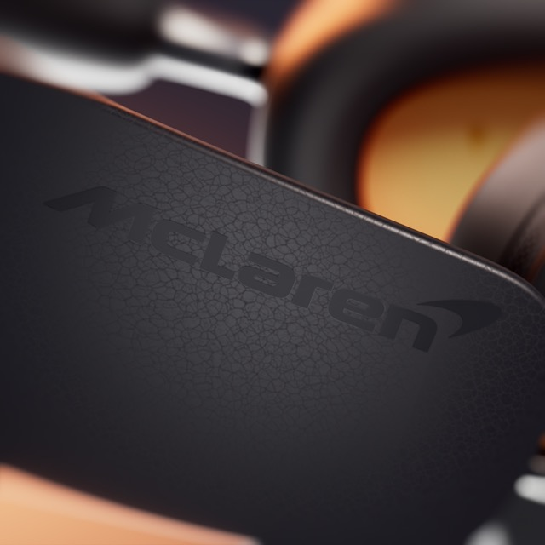

The iconic design and class-leading sound quality of the new Px8 S2 McLaren Edition will be available from the 19th November, from the Bowers & Wilkins website and selected retailers, priced at $899 / £729 / €829.

- Ends -

Notes to Editors

About Bowers & Wilkins:

Bowers & Wilkins, founded in the U.K. in 1966, has been at the forefront of high-performance audio technology for more than 50 years. It designs and manufactures precision home speakers, headphones, custom installation and performance car audio products that set new standards for innovation and sound quality, earning countless awards and accolades from the world’s leading recording studios and musicians. Bowers & Wilkins’ reputation is based on the unwavering pursuit of the best possible sound and an unsurpassable music listening experience. Bowers & Wilkins joined the Sound United LLC family of brands in 2020. Learn more at www.bowerswilkins.com

About HARMAN:

HARMAN is a global leader in Lifestyle Audio and Automotive technology. We create intelligent experiences that enrich people’s lives on the road, in their homes, on the stage, and everywhere in between. Our iconic audio brands — including JBL®, Harman Kardon®, AKG®, Bowers & Wilkins®, Denon®, and Marantz® — bring premium sound to consumers and audio/visual professionals worldwide. More than 50 million vehicles globally rely on HARMAN’s technologies to deliver safer, smarter, and more intuitive in-cabin experiences. HARMAN is a wholly owned subsidiary of Samsung Electronics Co., Ltd. and has approximately 30,000 employees around the world.

Press contacts

John or Lucette Nicoll
Nicoll Public Relations
john@nicollpr.com, lucette@nicollpr.com
617-470-9906

Additional images can be downloaded here:
https://hub.soundunited.com/share/04108BE0-7DFB-4F4D-AEE2867A181AD922?viewType=grid

