Bowers & Wilkins introduces Px8 S2, the new flagship statement in wireless headphones

**The new Px8 S2 sets a new benchmark for performance and design in the wireless over-ear category. It’s the best headphone Bowers & Wilkins**

**has ever made.**

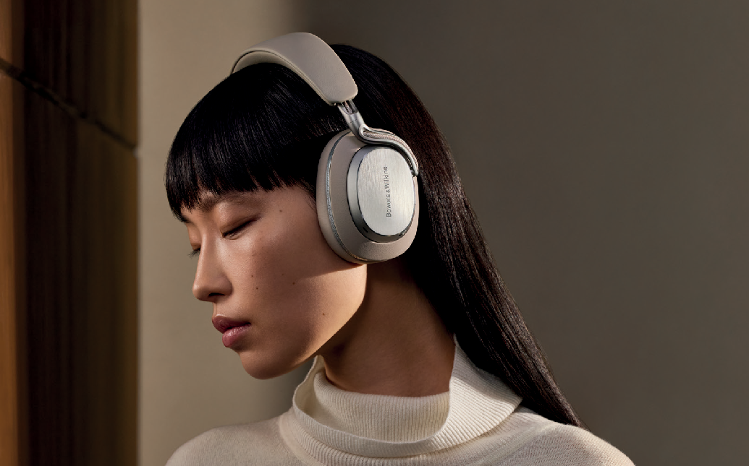

**Worthing, UK, 24th September 2025:** Bowers & Wilkins, the renowned British audio brand, is proud to launch its new flagship active noise cancelling wireless headphone – the Px8 S2.

Bowers & Wilkins is trusted by music professionals the world over to deliver the most detailed, natural and immersive sound available – the True Sound of the artist’s intent. The brand has a long-established pedigree in producing category-defining headphones, including the award-winning Px7 S3 and the reference-standard Px8.

Now, Bowers & Wilkins is proud to introduce the new flagship statement in wireless headphones: the Px8 S2. Elevating the brand’s iconic design DNA to new heights in the premium headphone category,

the Px8 S2 delivers the ultimate representation of Bowers & Wilkins’ revered performance, comfort and style.

Px8 S2’s thoughtfully evolved design and profile has been engineered for comfortable, extended listening, with a notably slimmer form than the outgoing Px8 – even the new carry case is more compact and easier to fit into your bag. As you would expect for a flagship Bowers & Wilkins product, the new Px8 S2 has been trimmed and finished to the highest possible standards. Luxurious Nappa leather covers every primary surface, while the aluminum arm mechanism with its new, exposed cable detailing, produces the perfect combination of light weight, optimized mechanical stiffness and exquisite design.

Px8 S2 is available in two refined Nappa leather finishes: Onyx Black and Warm Stone, each with

color-coordinated leather and aluminum detailing. To ensure long-term pride of ownership, Bowers & Wilkins has engineered the new design so that both ear cushions and headband are replaceable by trained

service engineers.

# The new reference standard in wireless headphone listening

Px8 S2 is the best sounding headphone the brand has ever created. Building on the critically acclaimed, multi-award-winning pedigree of Px7 S3, the new flagship model takes wireless headphone performance to all-new heights of resolution and insight. Its 40mm Carbon Cone drive units deliver a transformational listening experience by combining exceptionally low coloration and distortion with light weight, ensuring stunning detail and clarity plus effortless, powerful dynamics, whatever you’re listening to.

These drive units feature a comprehensively redesigned and improved chassis, voice coil, suspension and magnet, and are carefully angled to the listener’s ears to ensure a consistent distance from every point across the surface of each driver to each ear, ensuring better imaging and stereo spaciousness. They are powered by a dedicated, discrete headphone amplifier providing notably more scale and energy to the sound.

Building on that high-quality acoustic platform, Px8 S2 includes both aptXTM Adaptive 24/96 wireless technology and the latest Qualcomm innovation, aptX Lossless. Both technologies can automatically optimize wireless music transmission from compatible phones, tablets and computers, ensuring the best possible sound quality with high-resolution music streaming services such as Amazon Music, Qobuz and TIDAL, which are available to stream directly from the Music app.

Supported by powerful Bowers & Wilkins-developed DSP (Digital Signal Processing), the result is outstanding 24-bit / 96 kHz high-resolution sound quality. 3.5mm analogue audio connections are also supported, as is high-resolution-capable USB-C – a great benefit for both computer users and owners of compatible mobile devices, including the latest generation of iPhone. Both cable types are included in the carry case that accompanies the headphones.

# Block out the world

Bowers & Wilkins engineers are confident that the new active noise cancelling technologies developed for the Px7 S3 and Px8 S2 are the most powerful and effective the brand has ever developed. As is always the case, the chosen approach carefully balances effective cancellation of unwanted noise while doing no harm to the musicality of the performance – and in this new generation of headphones, the results are simply exceptional.

As with Px7 S3, the new Px8 S2 features eight high-performance microphones, carefully located around the periphery of each earcup and working together to deliver the best results. Two of them measure the output of each drive unit, four – positioned at opposite ends of each earcup for the best possible coverage – monitor ambient noise from the outside world, and two more provide outstanding voice clarity. Careful positioning and angling of those microphones enhances performance even in the noisiest environments. When making calls, unwanted noise is effectively suppressed by the latest generation of voice processing technology, ADI Pure Voice. All eight microphones work in conjunction with the noise cancelling and voice-processing technologies to ensure outstanding call clarity wherever you are.

# Enhanced features

Offering 30 hours of battery life with full noise cancellation on, Px8 S2 can play all day long – and more – on just a single charge, while a 15-minute quick recharge is sufficient to provide up to seven hours of additional listening time.

As with all other current generations of Bowers & Wilkins headphones and earbuds, the Px8 S2 can be configured and controlled using the brand’s Music app. You can activate or disengage the noise-cancelling transparency mode to let in more or less of the outside world, monitor the headphone’s charge levels, select the wear sensor sensitivity and define your preferred operation for the physical ‘Quick Action’ button on the headphones. Listeners can now opt to fine-tune the sound through an adjustable five-band EQ, complete with the option to store their preferred settings as easily accessible presets. If preferred, the EQ option can be bypassed by selecting the True Sound mode, which represents the preferred audio tuning selected by the acoustic team at the Southwater Research Establishment (SRE).

As with Px7 S3, physical controls on each earcup are also included, ensuring full control even without the Music app. The revised button layout, which reshapes the volume up, volume down and play/pause buttons to improve their tactile interaction and relocates the power button to the left-hand earcup, is more intuitive to

use than ever. The Quick Action button allows users to either quickly cycle through the Px8 S2’s noise-cancelling options – Off, Pass-Through and On – or seamlessly launch their phone’s Voice Assistant at the touch of a button.

Px8 S2 is future-proof, too. Bowers & Wilkins will roll out a series of over-the-air updates later this year, the first of which will include support for spatial audio listening. Bluetooth® LE Audio, complete with AuracastTM broadcast functionality, will be added later.

Commenting on the launch, **Giles Pocock**, VP of Brand Marketing, said: “*We are incredibly proud to launch the Px8 S2, the best headphone we have ever created. When we introduced the Px8 in 2022, it redefined what was possible in wireless headphone performance. The Px8 S2 sets the benchmark once again, recalibrating expectations for sound quality, design, and craftsmanship. It’s the ultimate expression of our mission: to bring listeners even closer to the artist’s performance – and of course, the beautiful design and finish only adds to that real pride of ownership.*”

The all-new Px8 S2 is available from 24th September from bowerswilkins.com and select third-party retailers for $799.

Download high-resolution images here:

<https://hub.masimoconsumer.com/share/A055D8A5-CAFE-4427-A83C76BC31CA299C/?viewType=grid>

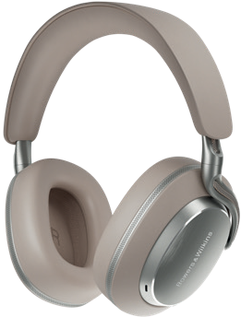 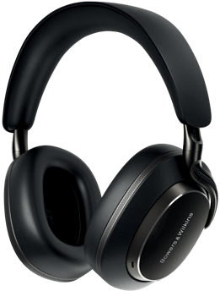

Px8 S2 Warm Stone Px8 S2 Onyx Black

# Notes to Editors:

**Px8 S2**

* Carbon Cone drive units with dedicated headphone amplifier
* aptX Adaptive 24/96 and aptX Lossless compatible
* Proprietary high-performance ANC, with eight-microphone array
* Bowers & Wilkins Music app provides set-up and control
* 30 hours’ battery life from a single charge, plus 15-minute fast recharge for seven hours’ listening
* Spatial audio upgrade will be released later this year, with LE Audio to follow
* Available in Onyx Black and Warm Stone

# About Bowers & Wilkins

Bowers & Wilkins, founded in the U.K. in 1966, has been at the forefront of high-performance audio technology for almost 60 years. It designs and manufactures precision home speakers, headphones, custom installation and performance car audio products that set new standards for innovation and sound quality, earning countless awards and accolades from the world’s leading recording studios and musicians. Bowers & Wilkins’ reputation is based on the unwavering pursuit of the best possible sound and an unsurpassable music listening experience.

Learn more at [**www.bowerswilkins.com.**](http://www.bowerswilkins.com/)

For more information, please contact:

**John or Lucette Nicoll**

Nicoll Public Relations

[john@nicollpr.com](mailto:john@nicollpr.com), lucette@nicollpr.com

617-470-9906

Copyright © B&W Group Ltd. E&OE.

Download high-resolution images, fact sheets, and press release from the Bowers & Wilkins Hub.

The content in this news release is accurate at the time of publication but may be subject to change without notice. All trademarks mentioned in this news release are the property of their respective owners.

Copyright © B&W Group Ltd. E&OE Qualcomm is a trademark of Qualcomm Incorporated, registered in the United States and other countries. aptX is a trademark of Qualcomm Technologies International, Ltd, registered in the United States and other countries.