THIS INFORMATION IS EMBARGOED UNTIL 5 AM EST, APRIL 3rd 2025

Bowers & Wilkins introduces the Pi8 McLaren Edition, designed to take its award-winning earbuds to new heights of prestige and exclusivity
- The award-winning Bowers & Wilkins Pi8 wireless earbuds receive new McLaren-inspired styling complete with a Galvanic Gray and Papaya orange finish
- Pi8 McLaren Edition joins the renowned Px8 McLaren Edition and Zeppelin McLaren Edition in a portfolio of collaborative products inspired by the decade-long partnershipwith McLaren Automotive
Press Release
Press Release
- Bowers & Wilkins recently extended its relationship with McLaren Automotive to include the McLaren Formula 1 Team to become Official Audio Partner of McLaren, bringing the winning partnership to a new audience of F1 fans

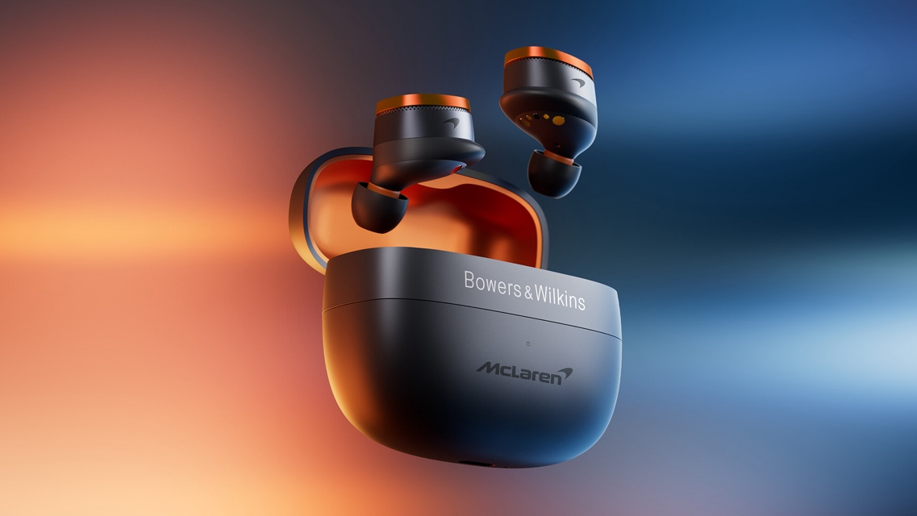

The Pi8 McLaren Edition, a new version of the award-winning Bowers & Wilkins Pi8 wireless earbuds has been unveiled, developed in collaboration with McLaren Automotive and the McLaren Formula 1 Team. The new earbuds build on the success of the award-winning Pi8, integrating the famous McLaren Papaya orange together with Galvanic Gray into the design.

Award-winning sound meets iconic McLaren design
Reflecting the two brands’ shared technical and performance-led aesthetic, the Pi8 McLaren Edition offers the high-performance sound quality synonymous with
Bowers & Wilkins, coupled with a design that connects fans of McLaren cars to the visual identity of the McLaren brand.

The Pi8 is the Bowers & Wilkins multi-award-winning flagship earbud combining reference-standard hi-res audio performance, elegant design, premium materials, exceptional comfort and fit, as well as enhanced connectivity and features, including Wireless Audio Retransmission.

F1 is well-known for its globetrotting nature, so Bowers & Wilkins products will play a crucial role in both the team’s extensive travel from race-to-race, relaxation and recovery, as well as any pre-race preparation needs throughout the season.

Speaking on behalf of Bowers & Wilkins, Giles Pocock, Vice President of Brand Marketing, said: “We are thrilled to collaborate with the McLaren team once again. This reimagining of our award-winning earbuds elevates our long-term partnership even further by combining the unmistakable design DNA of McLaren with our industry-leading audio products to create an attention-grabbing version of our Pi8. We’re excited to see how it’s received by Bowers & Wilkins and McLaren fans alike.”

A long-standing partnership rooted in prestige and performance

Since 2015, Bowers & Wilkins and McLaren have partnered to develop the high-performance audio systems found in McLaren’s supercars. The relationship is built on firm technical foundations and rooted in the brands’ shared values of delivering the highest levels of performance. More recently, the strategic long-term multi-year partnership was extended to see Bowers & Wilkins’ become McLaren's Official Audio Partner across McLaren Automotive and the McLaren Formula 1 Team.

Bowers & Wilkins’ pursuit of perfection, inspired by founder John Bowers, mirrors the unyielding precision and performance demanded in Formula 1 racing and the audio brand’s engineering team worked closely with their counterparts at McLaren Automotive to create and optimise the audio system found in the McLaren W1, the company’s new high-performance supercar. The audio system in the W1 features the latest advanced speaker technologies developed at the Bowers & Wilkins’ Southwater research and development centre, including the Continuum Cone, as found in the brand’s flagship 800 Series Diamond loudspeakers.

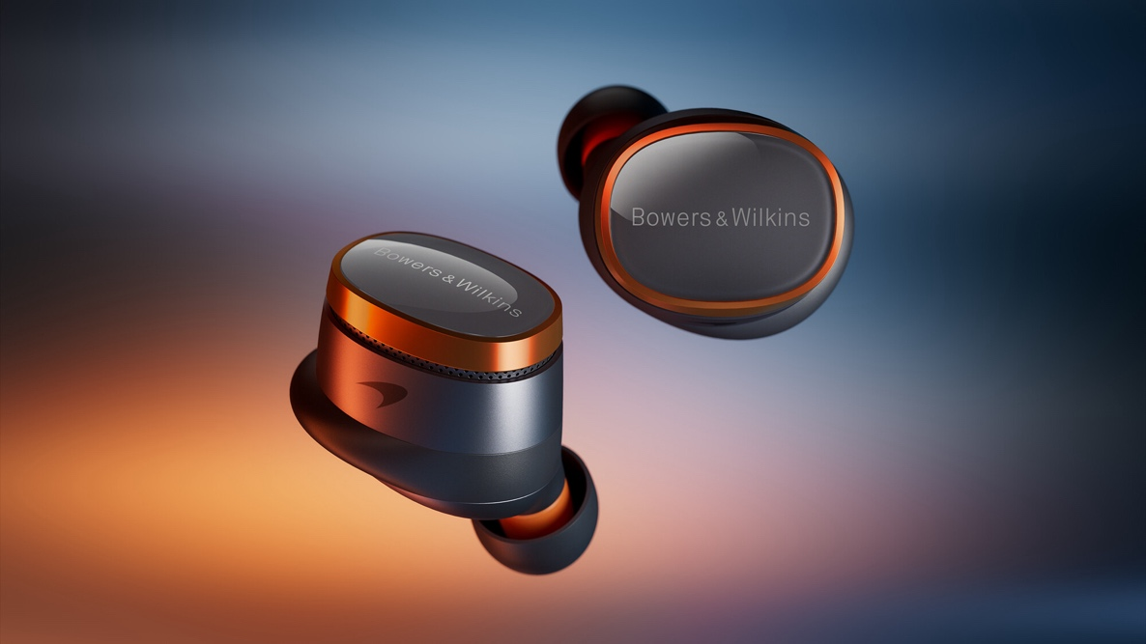

The Pi8 McLaren Edition is available with limited pre-sale availability and for pre-order from April 3rd, via the Bowers & Wilkins website www.bowerswilkins.com. Pricing is $499.

Ends

Notes to Editors

About Bowers & Wilkins:

Bowers & Wilkins, founded in the U.K. in 1966, has been at the forefront of high-performance audio technology for more than 50 years. It designs and manufactures precision home speakers, headphones, custom installation and performance car audio products that set new standards for innovation and sound quality, earning countless awards and accolades from the world’s leading recording studios and musicians. Bowers & Wilkins’ reputation is based on the unwavering pursuit of the best possible sound and an unsurpassable music listening experience. Bowers & Wilkins joined the Sound United LLC family of brands in 2020. Learn more at www.bowerswilkins.com

About McLaren Automotive:
McLaren Automotive is a producer of ultra high-performance, lightweight supercars. Launched in 2010, the company is now the largest part of the McLaren Group.

Headquartered at the McLaren Technology Centre (MTC) in Woking, Surrey, England, McLaren Automotive is driven by the challenge of creating the world’s most exhilarating, engaging and benchmark setting vehicles. Leveraging over 60 years of history in authentic, racing performance, McLaren has delivered some of the most spectacular supercars ever made.

The company’s product portfolio of GTS, supercar, Motorsport and Ultimate models are retailed in over 40 markets around the world. Its cars are assembled by hand at the McLaren Production Centre (MPC), based on the same campus as MTC in Woking.

McLaren is a pioneer that continuously pushes the boundaries. In 1981, it introduced lightweight and strong carbon fibre chassis technology into Formula 1 with the McLaren MP4/1.

Then in 1993 it designed and built the legendary McLaren F1 road car. Built around a carbon fibre chassis, it established McLaren’s supercar DNA, realised for the 21st century in 2011 with the introduction of the McLaren 12C – McLaren Automotive’s first production car.

McLaren was the first to deliver a hybrid hypercar, the McLaren P1™, in 2013. Launching the Ultimate Series of vehicles, P1™ was followed by the McLaren Senna in 2018 and its track-only GTR derivative followed a year later. 2019 also saw the introduction of the Speedtail hybrid hyper-GT and at the end of the year the open-cockpit Elva roadster – the lightest McLaren road car ever – was announced.

McLaren’s LT models represent the ultimate expression of track performance in series production supercars. Limited in volume, they are distinguished by a name coming from the ‘Longtail’ version of the F1 GTR, which first raced in 1997. The LT designation was incorporated into McLaren Automotive nomenclature in 2015 with the arrival of the 675LT coupe and 675LT Spider. In 2018, the McLaren LT portfolio grew with the announcement of the 600LT, and in 2020 and 2021 respectively the 765LT coupe and 765LT Spider were introduced.

Also in 2021, the company unveiled its all-new high-performance hybrid supercar, the McLaren Artura. The Artura is the first McLaren to benefit from the McLaren Carbon Lightweight Architecture (MCLA). The MCLA is designed, developed and manufactured at the McLaren Composites Technology Centre in the Sheffield region of England using world-first processes and will spearhead the brand’s electrified future.

2022 saw McLaren announce the Solus GT, a single-seat, closed-cockpit track car which brought to life a futuristic concept that was originally created for virtual gaming.

In 2023, McLaren unveiled its lightest and most powerful series-production supercar, the 750S – a thorough development of the award-winning 720S supercar. McLaren also introduced the new GTS, replacing the McLaren GT.

The McLaren Artura Spider was revealed in early 2024 as the brand’s first high-performance hybrid convertible. Its introduction was part of a major model year uplift for the Artura nameplate, and meant McLaren’s series-production line-up of GTS, new Artura and 750S had been introduced within 12 months of each other.

A new chapter in the McLaren ‘1’ car story was announced in October 2024, with the reveal of the McLaren W1 supercar. A clear successor to the McLaren F1 and McLaren P1TM, the W1 is the manifestation of McLaren’s World Championship mindset, with epic power and performance and new heights of dynamic and aerodynamic excellence.

McLaren Automotive also chooses to partner with like-minded, world-leading companies and organisations who push the boundaries in their respective fields. These include Ashurst, Bowers & Wilkins, Dynisma, Gulf, Pirelli, Richard Mille and Tumi.

About McLaren Racing

McLaren Racing was founded by racing driver Bruce McLaren in 1963. The team entered its first Formula 1 race in 1966. McLaren has since won 21 Formula 1 world championships, 189 Formula 1 grands prix, the Indianapolis 500 three times, and the Le Mans 24 Hours at its first attempt.

McLaren Racing competes across five racing series. The team competes in the FIA Formula 1 World Championship with McLaren F1 drivers Lando Norris and Oscar Piastri, the NTT INDYCAR SERIES with Arrow McLaren drivers Pato O’Ward, Nolan Siegel and Christian Lundgaard, the ABB FIA Formula E World Championship as the NEOM McLaren Formula E Team with drivers Sam Bird and Taylor Barnard, and F1 Academy with Driver Development programme member Ella Lloyd. The team also competes in the F1 Sim Racing Championship as McLaren Shadow with Lucas Blakeley, Wilson Hughes and Alfie Butcher.

McLaren is a champion for sustainability in the sport and a signatory to the UN Sports for Climate Action Commitment. It is committed to achieving net zero by 2040 and fostering a diverse and inclusive culture in the motorsport industry.

McLaren Racing – Official Website

For more information, please contact:

Nicoll Public Relations
John Nicoll/Lucette Nicoll
john@nicollpr.com
lucette@nicollpr.com
1+781-789-6000

Download high-resolution images from the Bowers & Wilkins Hub:
https://hub.masimoconsumer.com/share/7CBB9603-A3A9-4D6F-9BB8E3B90659A8A6?viewType=grid

