

Bowers & Wilkins upgrades its iconic Zeppelin with new Pro model

**Revised engineering, improved sound quality and enhanced finishes add even**

**more to the award-winning wireless speaker’s enduring appeal**

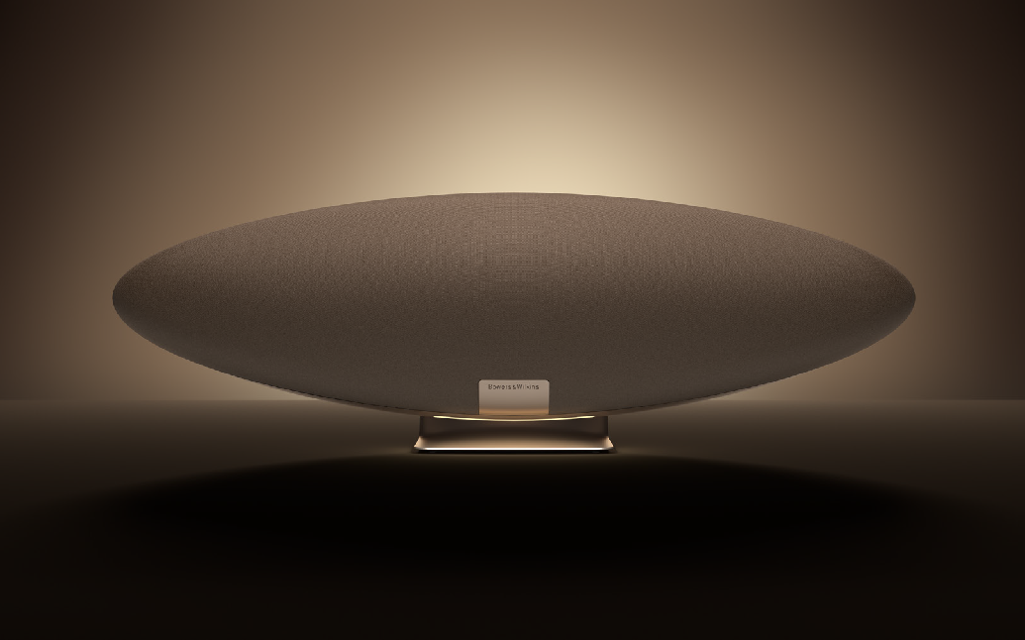

**Worthing, UK—October 15, 2024:** The most recent version of the iconic Bowers & Wilkins Zeppelin has already met with huge critical acclaim for its outstanding combination of spectacular design, superlative performance and superior smart features.

Now, Bowers & Wilkins is proud to announce an even higher-performance version of its world-renowned wireless loudspeaker: introducing the new **Zeppelin Pro Edition.**

**Distinctive, innovative design**

The new Zeppelin Pro Edition builds on the iconic shape of the existing Zeppelin, adding some subtle but effective upgrades to the design that only add to its already considerable appeal, including two all-new finishes – Solar Gold and Space Grey – together with a revised downlight that now offers user-selectable choice over 15 separate colors, each with brightness adjustment options.

**Upgraded with award-winning Titanium Dome tweeter technology**

As with all Zeppelins, the new Zeppelin Pro Edition is a complete and powerful speaker system in one elegant enclosure. The key to its improved performance is the introduction of Titanium Dome tweeters – as found in the latest generation of the multi-award-winning 600 Series loudspeakers – which are mounted at the far edges of the enclosure and are fully isolated from vibrations running through the cabinet generated by other, larger drive units.

The new tweeters are paired with 90mm midrange drivers using Bowers & Wilkins proprietary

Fixed Suspension Transducer FST™ technology – as used in all the company’s premium floor-standing speakers. These drive units have been upgraded with increased cone damping, reducing the effects of cone break-up leading to a more open midrange sound. Along with revised DSP tuning designed to

make the most of the potential of these new drive units, the result is an even more revealing, room-filling

sound.

Finally, a 150mm subwoofer is on hand to add deep, detailed and refined bass to the open, high- resolution sound of the combined system. Mounted centrally at the heart of the Zeppelin Pro Edition’s structure, its design is carefully optimized to avoid unwanted ‘rocking’ of the cabinet as it operates, resulting in a cleaner-sounding and more agile bass delivery.

**Great sound throughout your home**

The Zeppelin Pro Edition has multiroom functionality built in. Use it with both other new Zeppelins in a multiroom environment or, if you prefer, a multiroom system based on Bowers & Wilkins’ own Formation range of high-resolution wireless speakers. Able to stream via AirPlay2™, Bluetooth aptX™ Adaptive and Spotify Connect™, the Zeppelin also gives users access to all the music streaming services available from the Bowers & Wilkins Music app, including Deezer, Last.fm, Qobuz, TIDAL, TuneIn and many more. This also means seamless interaction with Bowers & Wilkins’ award-winning range of wireless headphones or earbuds, which can also be controlled by the same Music app.

More stylish than ever and even more remarkable to listen to, the new, upgraded Zeppelin Pro Edition is

available from 15th October in Space Grey or Solar Gold from [www.bowerswilkins.com.](http://www.bowerswilkins.com/)

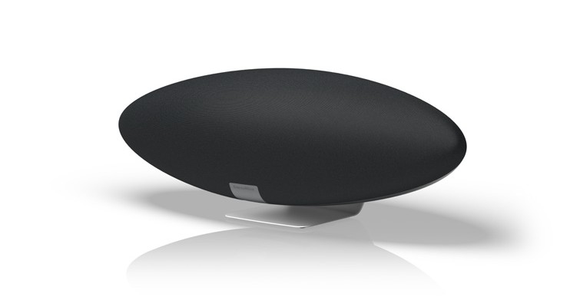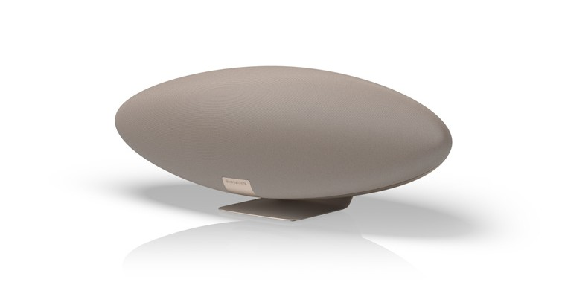

**$799 USD**

**Notes to Editors:**

**About Bowers & Wilkins**

Bowers & Wilkins, founded in the UK in 1966, has been at the forefront of high-performance audio technology for more than 50 years. It designs and manufactures precision home speakers, headphones, custom installation and performance car audio products that set new standards for innovation and sound quality, earning countless awards and accolades from the world’s leading recording studios and musicians. Bowers & Wilkins’ reputation is based on the unwavering pursuit of the best possible sound and an unsurpassable music listening experience.

Learn more at [**www.bowerswilkins.com.**](http://www.bowerswilkins.com/)

**For more information, please contact:**

**Nicoll Public Relations**

**John Nicoll/Lucette Nicoll**

[john@nicollpr.com](mailto:john@nicollpr.com)

[lucette@nicollpr.com](mailto:lucette@nicollpr.com)  
 1+781-789-6000

**Download high-resolution images from the Bowers & Wilkins Hub**[**. Here:**](https://hub.masimoconsumer.com/share/527C2FA8-5C42-4328-B4F6B65165CC26AE/?viewType=grid)

Copyright © B&W Group Ltd. E&OE.

The content in this news release is accurate at the time of publication but may be subject to change without notice.

All trademarks mentioned in this news release are the property of their respective owners. Copyright © B&W Group Ltd. E&OE

iPod and AirPlay are trademarks of Apple Inc., registered in the U.S. and other countries. IOS is a trademark or registered trademark of Cisco in the U.S. and other countries and is used under license. The Bluetooth® word mark and logos are registered trademarks owned by Bluetooth SIG,Inc. and any use of such marks by Bowers & Wilkins is under license. Other trademarks and trade names are those of their respective owners. Qualcomm is a trademark of Qualcomm Incorporated, registered in the United States and other countries.

aptX is a trademark of Qualcomm Technologies International, Ltd., registered in the United States and other countries.

Qualcomm is a trademark of Qualcomm Incorporated, registered in the United States and other countries. aptX is a trademark of Qualcomm Technologies International, Ltd., registered in the United States and other countries.