
THIS RELEASE IS UNDER EMBARGO UNTIL 03:00AM EST, 30TH MAY 2024

Bowers & Wilkins and David Beckham: Bringing Together Two British Symbols
of Style and Performance
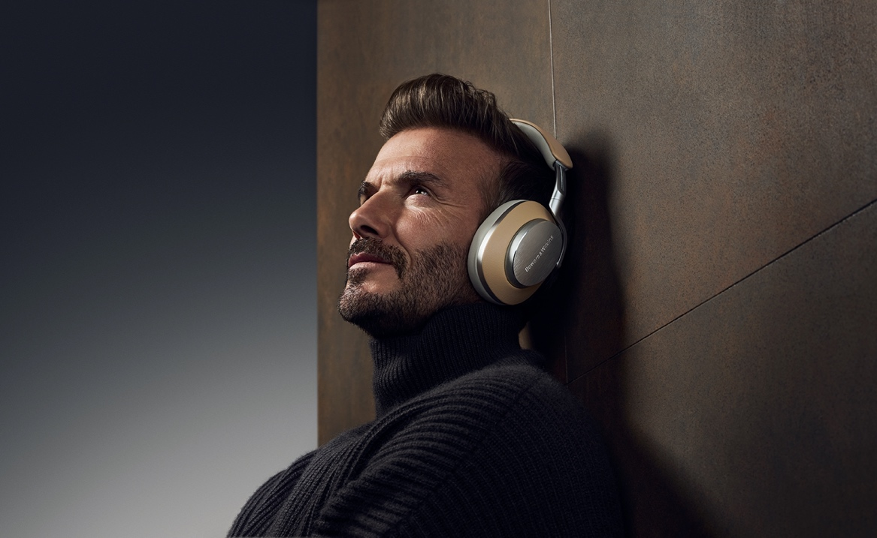
David Beckham wears Bowers & Wilkins’ award-winning Px8 wireless headphones
Worthing, UK, 30th May 2024: British audio brand Bowers & Wilkins and global icon David Beckham have partnered to create a unique alliance of style and sound, where David’s refined taste meets Bowers & Wilkins’ unwavering pursuit of perfection.
The announcement marks the start of a long-term partnership that will explore David Beckham’s relationship with music and the special role it plays in his life. As a long-term fan of the brand, David Beckham chose to collaborate with Bowers & Wilkins because of its unrivalled reputation for audio excellence, craftmanship and class-leading, premium design.
David Beckham said: “I’ve been a fan of Bowers & Wilkins for years and a proud owner of many of its products. Performance and design have always been important to me, which is why this partnership felt like such a natural fit.”
From his parents’ musical influences, through to his successful football career, music has always been important to David, where it provided the soundtrack to some
of his greatest performances on the pitch and marked special moments for
him and his family.
“Music has always played a huge role in my life. I can hear a track and remember exactly where I was and what I was doing. In our family, whenever special moments happen, there's always a song to go with them.”
David Beckham
Discover more about the partnership at bowerswilkins.com/davidbeckham

Notes to Editors
About Bowers & Wilkins
Bowers & Wilkins, founded in the UK in 1966, has been at the forefront of high-performance audio for more than 50 years. Bowers & Wilkins designs and manufactures precision home speakers, headphones, custom installation and performance car audio products that set new standards for innovation and sound quality, earning countless awards and accolades from the world’s leading recording studios and musicians. Bowers & Wilkins’ reputation is based on the unwavering pursuit of the best possible sound and an unsurpassable music listening experience. Learn more at bowerswilkins.com.
About David Beckham
David Beckham is one of England’s most successful footballers. With a career spanning 20 years, David has played with some of the most successful clubs in the world, including Manchester United and Real Madrid, as well as the England team, which he captained for six years. David was the first English player to have won league titles in four countries: England, Spain, the United States and France.
In 2018, David fulfilled a life-long ambition to be an owner of a football club when his group was awarded the Major League Soccer Franchise for the city of Miami. Inter Miami CF was officially announced in September 2018 with David as President of the Club.
Throughout his life, David has been committed to supporting charities and projects that seek to drive change for the better. David has worked with UNICEF for nearly 20 years as a Goodwill Ambassador, a role that promotes and protects the rights of the world’s most vulnerable children. In 2015, David launched the 7 Fund with UNICEF - a unique partnership to give vulnerable and disadvantaged children the opportunity to reach their full potential. David also campaigns for Malaria No More, using his platform to ensure the world and its leaders hear the urgent message of the malaria fight. While, in his position as Ambassadorial President of the British Fashion Council (BFC), David helps promote and nurture British fashion and the UK’s creative industries.
For more information, please contact:

Jack Howells
Brand Communications Manager, Bowers & Wilkins
+44 (0) 7764 611424
jack.howells@soundunited.com

Ellen Marchant
Senior Director, Communications, Authentic Brands Group
+44 (0) 7812 912573
emarchant@authentic.com

