Bowers & Wilkins and McLaren Automotive celebrate the enduring success of their partnership with the new Zeppelin McLaren Edition

- The award-winning Bowers & Wilkins Zeppelin wireless speaker has received new
McLaren-inspired styling featuring a Galvanic Grey and Papaya Orange finish

- Zeppelin McLaren Edition joins the hugely successful Px8 McLaren Edition in a portfolio of collaborative products inspired by the long-standing partnership

- The launch also introduces upgraded multi-room connectivity for the Zeppelin

- Sixty limited-edition models, inspired by 60 years of McLaren and featuring the iconic Speedy Kiwi logo as a reference to Bruce McLaren’s legacy, are exclusively available from select McLaren dealerships
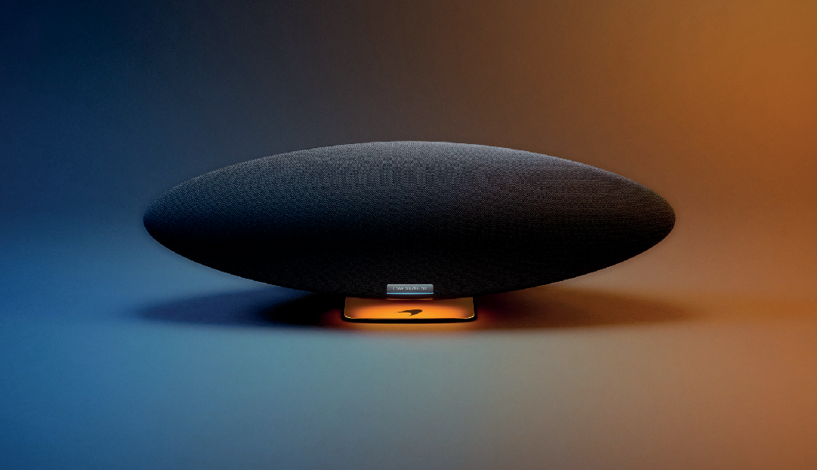

Worthing, UK, 11th October 2023: Bowers & Wilkins, the renowned British premium audio brand, has launched a new version of its award-winning wireless speaker in collaboration with long-standing partner, McLaren Automotive. Introducing the new Zeppelin McLaren Edition.

The new McLaren-inspired version celebrates both the partnership between two leading performance brands and McLaren’s 60th anniversary.

Best-in-class sound meets iconic McLaren design
Following the success of the Px8 McLaren Edition headphone, Bowers & Wilkins has created a specially designed version of its Zeppelin wireless speaker, featuring a refined Galvanic Grey finish and subtle Papaya Orange highlights inspired by McLaren Automotive’s design approach.

Reflecting McLaren’s technical and performance-led aesthetic, the Zeppelin McLaren Edition offers the high- performance sound quality synonymous with Bowers & Wilkins, coupled with a design that connects fans of McLaren cars to the visual identity of the McLaren brand.

Reimagined for the streaming age
The Zeppelin is a complete stereo system in one component, a wireless smart speaker reimagined for the streaming age. It features reference-quality drive unit technologies arranged in dedicated left and right speaker assemblies around a central, large subwoofer, all powered by 240W of amplification. The result is room-filling stereo sound no single-box rival can match.

Combining proven drive unit technology with its high-resolution streaming platform, the overall result is exceptional music performance whether from a wirelessly connected source or via a streaming service.

For more information, please contact:

Nicoll Public Relations
John Nicoll/Lucette Nicoll
john@nicollpr.com
lucette@nicollpr.com
1+781-789-6000

Download high-resolution images from the Massimo Hub.

The content in this news release is accurate at the time of publication but may be subject to change without notice. All trademarks mentioned in this news release are the property of their respective owners. Copyright © B&W Group Ltd. E&OE
Upgraded multi-room capability and new streaming services
Coinciding with the launch of the new Zeppelin McLaren Edition, Bowers & Wilkins has introduced wireless multi-room capability. The new model, along with all compatible Zeppelins, will now benefit from extended multi-room compatibility with both the Panorama 3 and the Formation portfolio of wireless speakers. This allows Bowers & Wilkins users to seamlessly connect and configure their in-home wireless speaker system, all easily set-up and controlled via the Bowers & Wilkins Music app for ultimate convenience.

Inspired by 60 years of McLaren
Bowers & Wilkins is also announcing a limited-production version of the Zeppelin created to celebrate the 60th anniversary of McLaren and Bruce McLaren’s legacy. Only sixty pieces of the Zeppelin McLaren 60th Anniversary Edition will be produced.

This limited-edition version features racing livery-inspired colors, including a vibrant orange finish, giving the Zeppelin’s instantly recognizable silhouette an even more distinctive aesthetic, while a Speedy Kiwi on the rear of the product pays homage to Bruce McLaren’s pioneering vision. The sixty limited-edition models are available exclusively from select McLaren dealerships worldwide.

A long-standing partnership rooted in performance
Since 2015, Bowers & Wilkins has been responsible for the development of the high-performance
audio systems found in McLaren Automotive’s supercars and hypercars. The partnership is built on firm technical foundations, while being rooted in both brands’ shared values of delivering the highest levels of performance possible.

Most recently, Bowers & Wilkins has worked closely with McLaren’s design and engineering teams to create and optimize the audio system found on the company’s latest supercar ¬– the McLaren 750S. Like its predecessors, the 750S features the latest speaker technologies, developed in Southwater, home to the Bowers & Wilkins research and development team since 2019 and only 30 miles from the McLaren Technology Centre in Woking.

Dan Shepherd, VP of Licensing & Partnerships for Bowers & Wilkins, commented: “I am thrilled to introduce the latest addition to our expanding product portfolio developed in collaboration with our partners at McLaren Automotive. The Zeppelin McLaren Edition joins the highly successful Px8 McLaren Edition, creating a uniquely appealing and innovative wireless product range that I’m sure will find eager buyers amongst both fans of McLaren and fans of Bowers & Wilkins alike.”

The Zeppelin McLaren Edition is available October 11th from the Bowers & Wilkins website and selected retailers at $899 while the limited-edition 60th Anniversary model is available from select McLaren dealerships.
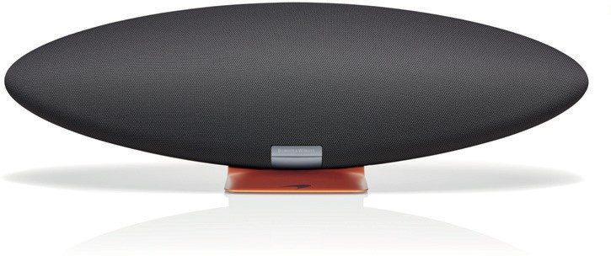
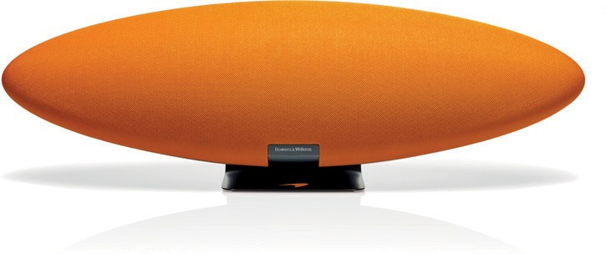
Zeppelin McLaren Edition Zeppelin McLaren 60th Anniversary Edition

Notes to Editors:

About Bowers & Wilkins
Bowers & Wilkins, founded in the UK in 1966, has been at the forefront of high-performance audio technology for more than 50 years. It designs and manufactures precision home speakers, headphones, custom installation and performance car audio products that set new standards for innovation and sound quality, earning countless awards and accolades from the world’s leading recording studios and musicians. Bowers
& Wilkins’ reputation is based on the unwavering pursuit of the best possible sound and an unsurpassable music listening experience. Learn more at www.bowerswilkins.com.

