Bowers & Wilkins introduces new Px8 in

luxurious Royal Burgundy finish
- Award-winning flagship Px8 noise cancelling wireless headphone now available in sumptuous Royal Burgundy Nappa leather finish with complementary gold detailing
- Hugely successful Tan and Black Nappa leather finishes continue unchanged
- The world-class acoustic team at Bowers & Wilkins has further optimized tuning for all Px8 models, successfully delivering even higher quality sound

Worthing, UK, 27th September 2023: Bowers & Wilkins, the renowned British premium audio brand, has launched a new finish of its industry-leading flagship wireless headphone, the multi-award-winning Px8. Now available in a Royal Burgundy Nappa leather finish, complemented by refined gold detailing, the Px8 continues to set the reference standard for sound, design, build and finish quality in the wireless headphone category.

The leader in premium headphone design
All three Px8 models continue to feature a single cast-aluminum arm structure that references Bowers & Wilkins’ signature design language, plus a diamond-cut bright edge on each elliptical logo plate. The earcups, memory-foam cushions and headband are all trimmed in soft, luxurious Nappa
leather for the ultimate comfort and a premium feel. Together, these design and material choices ensure that Px8 confidently asserts Bowers & Wilkins’ position as a premium audio brand like no other.
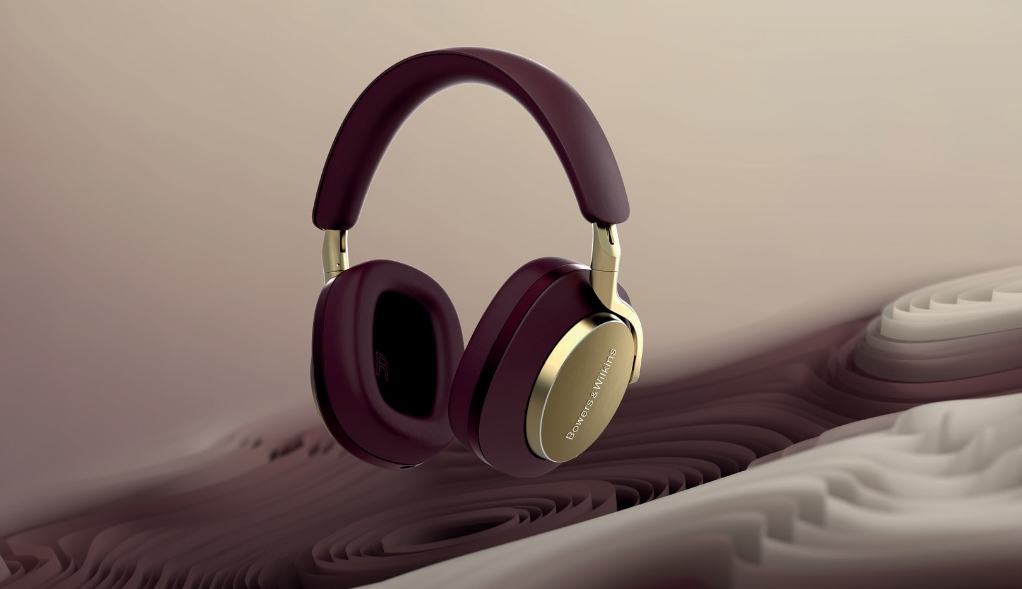

Unparalleled high-resolution sound
The Px8 delivers its award-winning sound thanks to ultra-high-performance 40mm Carbon Cone drive units, based on technologies cascaded from the brand’s reference-quality loudspeakers. It combines these with powerful Bowers & Wilkins-developed DSP (Digital Signal Processing) to deliver outstanding, 24-bit high-resolution sound quality from leading streaming services.

The new Px8’s revised acoustic tuning ensures even more detail, giving an unparalleled combination of ultra-fast response plus exceptionally low distortion throughout the frequency range. The result is resolution, realism and dynamics that surpasses the high bar set by both the Px7 S2 and the new Px7 S2e. This ensures an even more engaging and natural musical performance that brings the listener
closer than ever to the True Sound of the artist’s intent. Put simply, it’s the best sound quality Bowers & Wilkins has ever delivered from a pair of wireless headphones.

Available in the new Royal Burgundy plus existing Tan and Black Nappa leather finishes, the premium design and class-leading sound quality of the new Px8 is on sale from 27th September from the Bowers & Wilkins website and selected retailers priced $699.

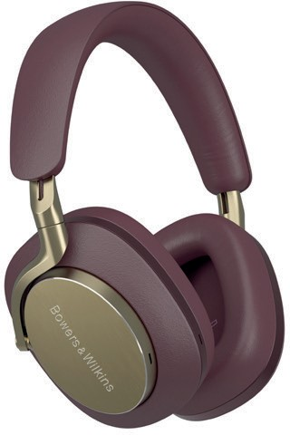
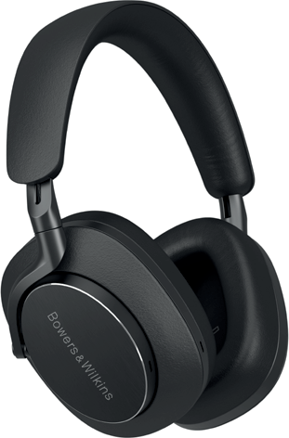
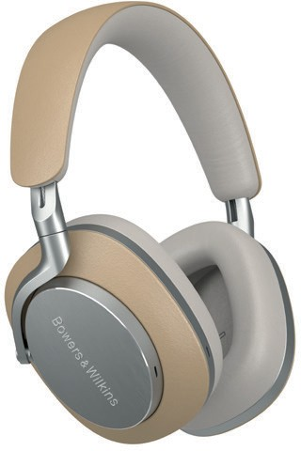

Px8 Royal Burgundy Px8 Black Px8 Tan

For more information, please
contact:

Nicoll Public Relations
John Nicoll/Lucette Nicoll
john@nicollpr.com
lucette@nicollpr.com
1+781-789-6000

Download high-resolution images here::

The content in this news release is accurate at the time of publication but
may be subject to change without notice. All trademarks mentioned in this news release are the property of their respective owners. Copyright © B&W Group Ltd. E&OE

Qualcomm aptX is a product of Qualcomm Technologies, Inc. and/ or its subsidiaries. Qualcomm
is a trademark of Qualcomm Incorporated, registered in the United States and other countries. aptX is a trademark of Qualcomm Incorporated, registered in the United States and other countries.

Notes to Editors:

About Bowers & Wilkins
Bowers & Wilkins, founded in the U.K. in 1966, has been at the forefront of high-performance audio technology for more than 55 years. It designs and manufactures precision home speakers, headphones, custom installation and performance car audio products that set new standards for innovation and sound quality, earning countless awards and accolades from the world’s leading recording studios and musicians. Bowers & Wilkins’ reputation is based on the unwavering pursuit of the best possible sound and an unsurpassable music listening experience. Learn more at www.bowerswilkins.com.

