Bowers & Wilkins introduces the new Px7 S2e, an evolution of its award-winning wireless

headphone with even better performance
- The new Px7 S2e, which replaces the Px7 S2, builds on the status of its multi-award-winning predecessor as one of the most highly rated wireless headphones in its category
- Upgraded high-performance DSP (Digital Signal Processing) and new sound tuning from the world-class engineering team at Bowers & Wilkins delivers significant advances in overall sound quality
- The new model features three evolved and refined finishes: Anthracite Black, Ocean Blue and
Cloud Grey, and introduces a fourth entirely new color, Forest Green
- Px7 S2e offers complete control via the Bowers & Wilkins Music App for set-up, fine-tuning
and direct music streaming plus user-adjustable EQ and Voice Assistant support
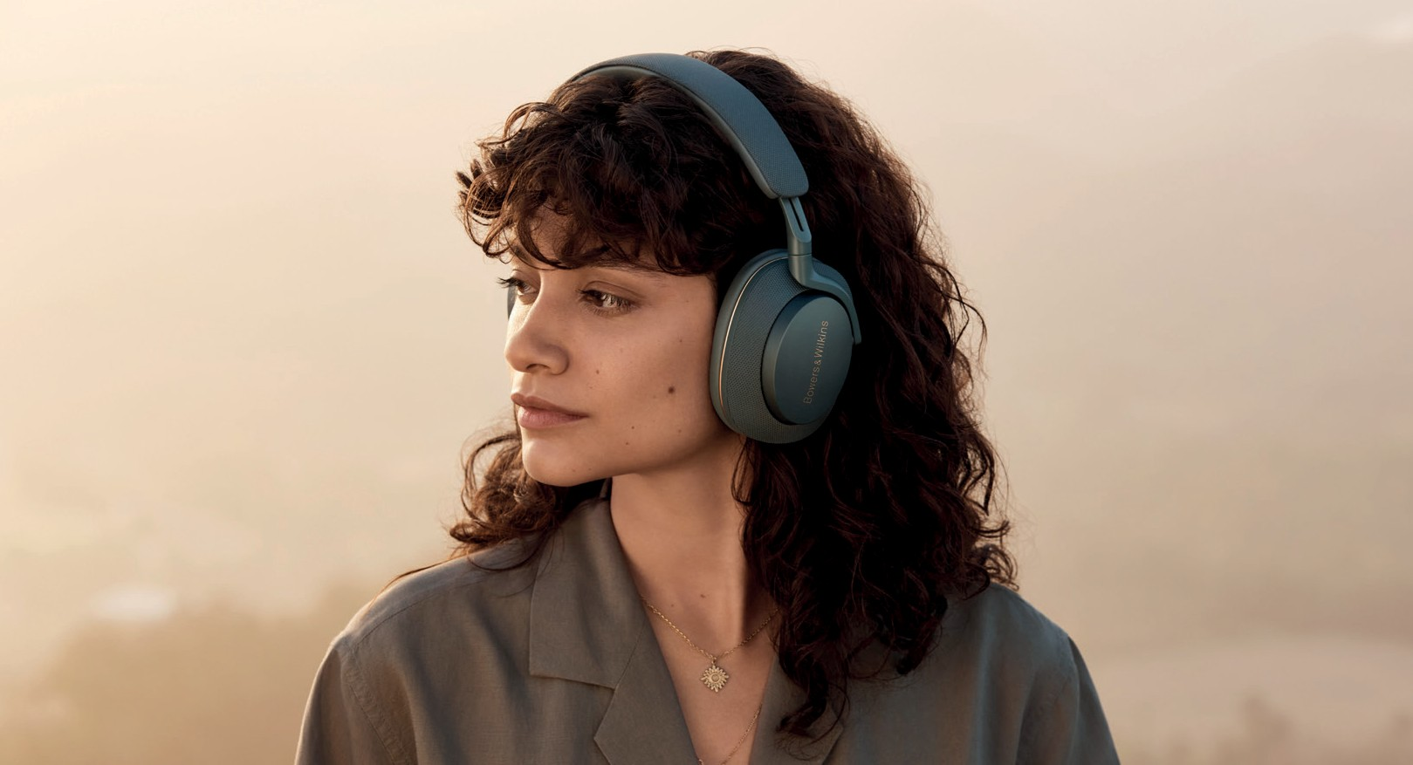

Worthing, UK, September 2023: Bowers & Wilkins, the renowned British premium audio brand, launches the Px7 S2e, an evolved edition of its award-winning active noise cancelling
wireless headphones.

Bowers & Wilkins has built an outstanding reputation for making headphones that deliver the most detailed, natural and immersive sound available – the True Sound of the artist’s intent. The new Px7 S2e is the latest addition to the brand’s highly successful portfolio of premium, performance-orientated headphones, all of which have been engineered with that same True Sound philosophy in mind.

Optimized for even better sound quality
The key to the Px7 S2e’s outstanding new sound quality is an extensively upgraded DSP (Digital Signal Processing) engine, optimized by Bowers & Wilkins to deliver exceptional performance with all types
of streamed music, including 24-bit high-resolution sound quality from suitable streaming services. The upgraded DSP has also given Bowers & Wilkins engineers the opportunity to retune the Px7 S2e’s acoustic platform to deliver unmatched detail, dynamics and spaciousness.

The Px7 S2e continues to use custom-designed 40mm drive units, specifically created to suit the requirements of headphone listening. The drivers offer an ultra-fast response – allowing them to faithfully reproduce every nuance in a piece of music – while remaining supremely low in distortion, resulting in
a more accurate presentation. The drive units are also carefully angled inside each earcup to ensure a consistent distance relative to the listener’s ear from every point across the surface of each driver, again producing a more natural and immersive soundstage.

Px7 S2e combines its powerful upgraded DSP and high-performance drive unit configuration with Qualcomm’s aptXTM Adaptive wireless technology to automatically optimize wireless music transmission from compatible phones, tablets and computers. USB-C and 3.5mm cable connections are also supported, with both cable types included in the carry case that accompanies the product.

For more information, please
contact:

Nicoll Public Relations
John Nicoll/Lucette Nicoll
john@nicollpr.com
lucette@nicollpr.com
1+781-789-6000

Download high-resolution images from the Massimo Hub.
https://hub.masimoconsumer.com/share/21EDB3E9-5AB0-4752-9500B3F5EEDDA364?viewType=grid

The content in this news release is accurate at the time of publication but may be subject to change without notice. All trademarks mentioned in this news release are the property of their respective owners. Copyright © B&W Group Ltd. E&OE

Qualcomm aptX is a product of Qualcomm Technologies, Inc. and/ or its subsidiaries. Qualcomm
is a trademark of Qualcomm Incorporated, registered in the United States and other countries. aptX is a trademark of Qualcomm Incorporated, registered in the United States and other countries.
Cancel unwanted noise, not your music
The Px7 S2e uses Bowers & Wilkins-optimized noise cancellation technology to effectively shut out unwanted noise without harming musicality. Six high-performance microphones work together to deliver the best results: two measure the output of each drive unit, two react to ambient noise from the outside world and two provide outstanding voice clarity with enhanced noise suppression for crystal clear calls. Careful positioning and angling of those microphones enhances performance even in the noisiest environments.

Music App offers complete control
As with all recently introduced Bowers & Wilkins headphones, the Px7 S2e works directly with the Bowers & Wilkins Music App for ultimate control, configuration, and a seamless user experience. The Music App can be used to pair Px7 S2e to a wide range of Bluetooth-enabled devices, fine-tune the sound through adjustable EQ, activate or disengage the noise-cancelling transparency mode to let in more or less of the outside world and finally, monitor the headphone’s charge levels. The Music App also includes direct music streaming from compatible streaming platforms, including Deezer, last.fm, NTS Radio, Qobuz, TIDAL and TuneIn, with more music services to be added soon. The Music App can also be used with other Bowers & Wilkins products, such as the acclaimed Zeppelin, affording users a seamless experience when switching between headphone and wireless speaker listening.

Physical controls on each earcup are also included, ensuring full control even without the App, while users can also use Px7 S2e to easily launch their phone’s Voice Assistant at the touch of a button. With 30 hours of battery life, Px7 S2e can play all day long – and more – on just one charge, while a 15-minute quick recharge provides up to seven hours of additional listening time. Android device users can also benefit from Google Fast Pair, with automatic support for Google’s Find My Device service should owners be unfortunate enough to mislay their headphones.

Premium finishes, ultimate comfort
Finally, to further celebrate the evolved design of the Px7 S2e, it’s available in four premium finishes: Anthracite Black, Ocean Blue, Cloud Grey and Forest Green, with all models featuring revised detailing coupled to high-quality materials, carefully designed for comfortable, extended listening. The new model retains its slim overall shape, light weight and luxurious memory foam earpads to perfectly encapsulate and cushion your ears for ultimate comfort, however long you are listening.

Commenting on the launch, Dave Sheen, Brand President of Bowers & Wilkins, said, “I’m delighted that the team has been able to build upon the excellence of Px7 S2. We always challenge ourselves to do better and with the new Px7 S2e our engineers have truly excelled themselves. I can’t wait to see our customers reaction to our latest headphone launch.”

Px7 S2e is on sale from September 19th for $399 from the Bowers & Wilkins website and select retailers. Learn more at www.bowerswilkins.com
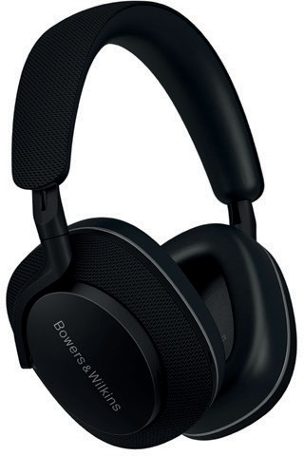
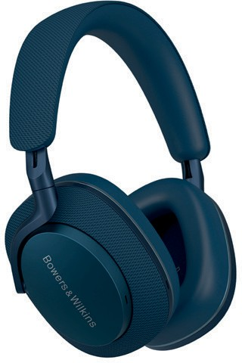
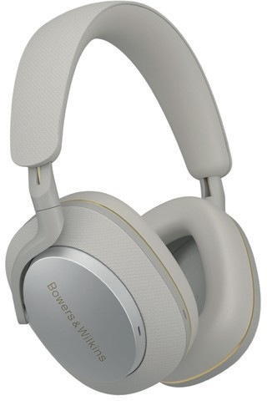
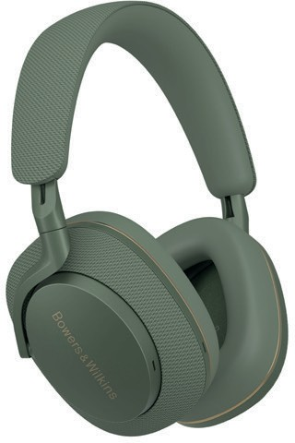

Px7 S2e Anthracite Black Px7 S2e Ocean Blue Px7 S2e Cloud Grey Px7 S2e Forest Green

Notes to Editors:

About Bowers & Wilkins
Bowers & Wilkins, founded in the U.K. in 1966, has been at the forefront of high-performance audio technology for more than 55 years. It designs and manufactures precision home speakers, headphones, custom installation and performance car audio products that set new standards for innovation and sound quality, earning countless awards and accolades from the world’s leading recording studios and musicians. Bowers & Wilkins’ reputation is based on the unwavering pursuit of the best possible sound and an unsurpassable music listening experience. Learn more at www.bowerswilkins.com.

