Bowers & Wilkins announces new

600 Series – the music lover’s first step into True Sound
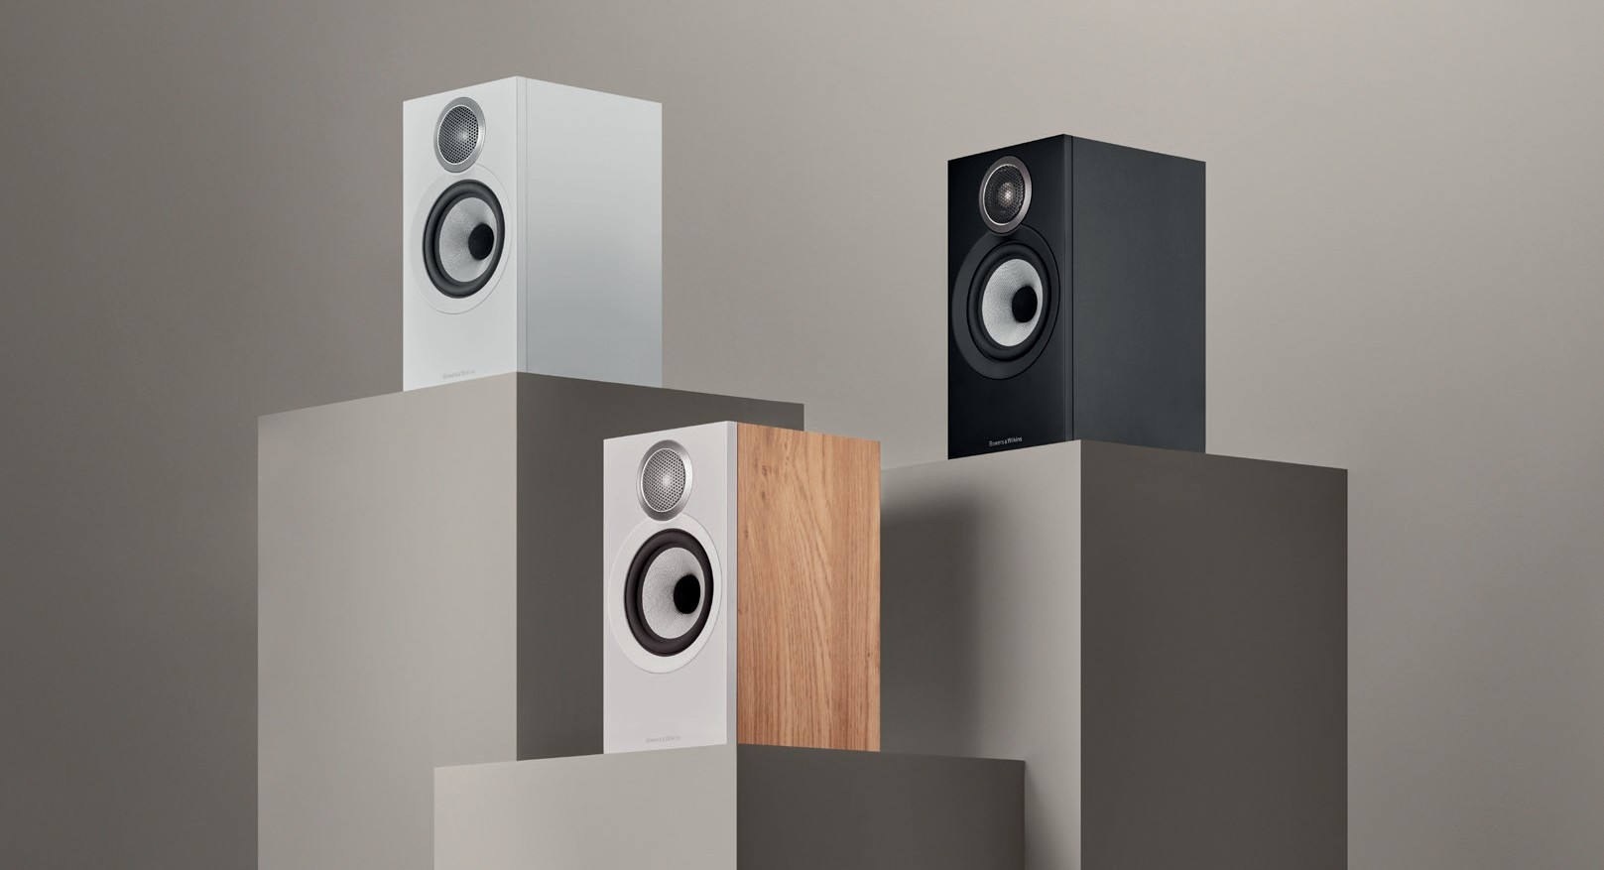
Worthing, UK, 23rd August 2023: How do you improve on a multi-award-winning loudspeaker range still considered as the best-in-category? World-renowned premium audio brand Bowers & Wilkins will build upon three decades of creating the reference standard in attainable yet high-performance loudspeakers with the launch of its new 600 Series S3. The eighth generation of one of hi-fi’s most acclaimed ranges features some of the most comprehensive upgrades the 600 Series has ever received.

The 600 Series has always played a critical role in the Bowers & Wilkins portfolio – not least as the company’s second-longest continuously available series after the iconic 800 Series Diamond. At a time when increasing numbers of listeners are demanding higher quality sound, either through vinyl or high- resolution streaming, the 600 Series S3 represents the perfect first step to experiencing the ‘True Sound’ of the artist’s intent – making it the ideal entry point into the Bowers & Wilkins brand.

The new range includes four distinct models: the floorstanding 603 S3, the 606 S3 standmount, the 607 S3 bookshelf speaker plus the HTM6 S3, a dedicated centre channel for home theatre. Each model is available in a choice of finishes, including Oak, White or Black – with a fourth Cherry finish available in APAC markets only. A new FS-600 floor stand is available in Silver or Black to complete the range.

All of the new models have been designed to work optimally together in various combinations as part of a 600 Series S3 Home Theatre System, integrating perfectly with the dedicated HTM6 S3 centre channel and one of the existing ASW608 or ASW610 active subwoofers.

All-new Titanium Dome Tweeter adds refinement and resolution
Bowers & Wilkins develops and manufactures all key loudspeaker components in-house and cascades those innovative technologies down over time. This approach continues with the new 600 Series S3 models, all of which feature comprehensive changes to every aspect of their acoustic performance. Many of the new components are derived from the 700 Series S3 and are fitted into a redesigned and improved cabinet construction.
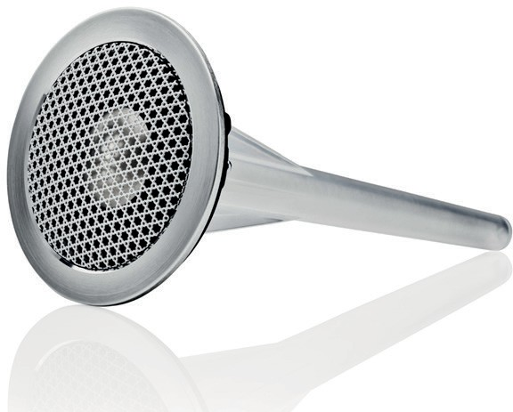
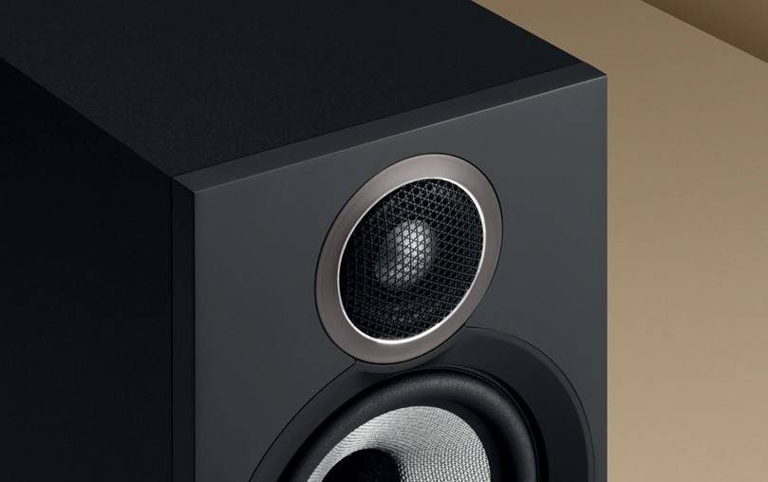

The most significant introduction to the new 600 Series S3 is an all-new tweeter dome technology, the Titanium Dome. The new tweeter is a two-part construction, with a very thin, light but rigid 25-micron main dome, braced by a second 30-micron titanium ring. This new design is housed in a significantly elongated tube-loading system, inspired by the design recently introduced in the new 700 Series S3. The longer tube loading system reduces the resonant frequency behind the dome and leads to a more open sound that is less impacted by the cabinet that houses it.

In addition, the new Titanium Dome benefits from a 700 Series S3-sized diaphragm mounting plate for better, more open dispersion and also includes the very latest, more open tweeter grille design taken directly from the recently introduced 800 Series Signature.

This combination of all these new technologies ensures that the new tweeter delivers a smoother, more refined sound without sacrificing resolution or detail.

Upgrades cascaded from the award-winning 700 Series range
Bowers & Wilkins’ proprietary Continuum Cones continue to feature throughout the new 600 Series S3 range with the addition of more powerful, lower distortion 700 Series S3 motor assemblies for midrange and bass/midrange drive units. The paper cone bass drivers in the 603 S3 also now feature 703 S3 motor systems. Crossovers are also updated with the inclusion of high quality, upgraded bypass capacitors from the 700 Series S3, delivering higher resolution and transparency.

The 600 Series S3 cabinets have also received extensive improvements. The tweeter and main drive units are now mounted closer together, using intersecting trim rings to improve integration and stereo imaging. On the rear of the speaker, a new terminal tray, taken from the 700 Series S3, is joined by a 700 Series specification bass port, improving performance and creating a stiffer cabinet. The enclosure’s rigidity is further improved by upgrading the internal bracing to a higher standard of wood. Finally, the bottom of the 606 S3 and 607 S3 now include metal threaded inserts so that the speakers can be more securely fixed to the top plate of the new FS-600 S3 stands.
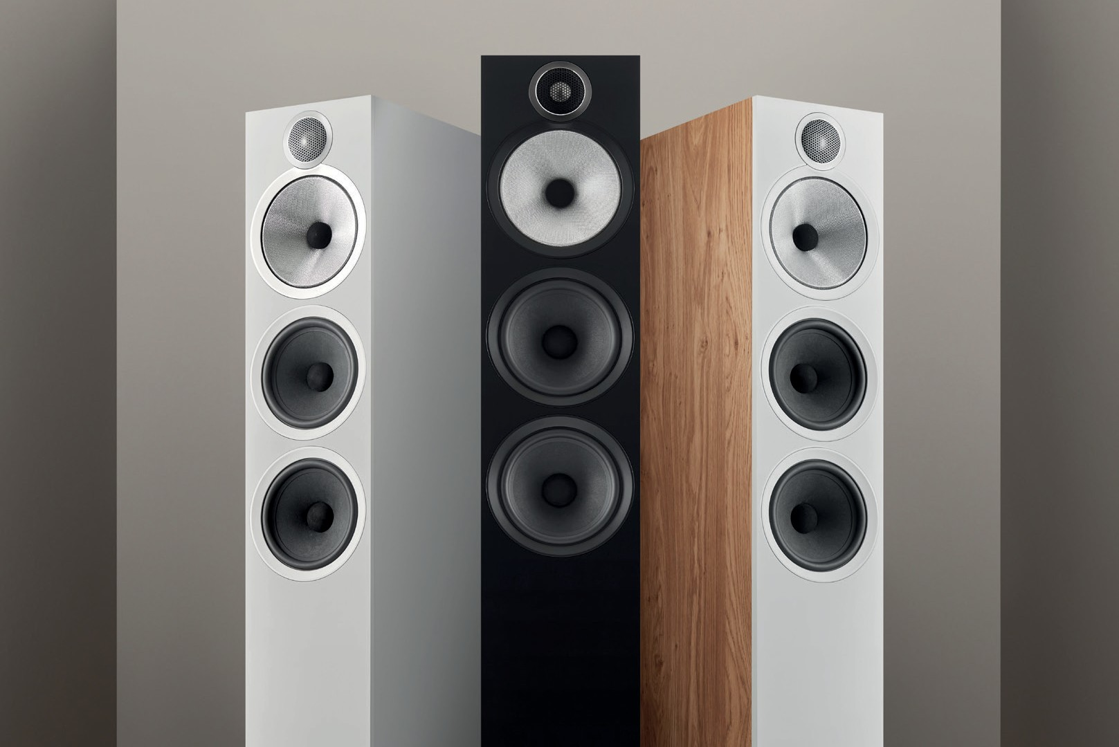

By developing all of these key technologies in-house, Bowers & Wilkins has been able to offer significant performance upgrades to all of its new range while maintaining outstanding value for money. Put simply, the 600 Series S3 continues to offer better quality components and technologies than any comparable competitor and is set to continue the legacy of the 600 Series as the reference standard in attainable yet high-performance loudspeakers. It’s the perfect first step into Bowers & Wilkins sound for music lovers everywhere.

Commenting on the launch, Dave Sheen, Brand President of Bowers & Wilkins said: “After nearly 30 years of continual evolution and improvement, we believe that the latest 600 Series S3 continues to set a benchmark in its category. Cascading key technologies down from our high-end loudspeaker ranges means everyone experiencing the new 600 Series will enjoy performance that genuinely delivers on our promise of True Sound and brings the listener closer than ever to the artist’s intent.”

The new 600 Series S3 range will be available from the 23rd August from bowerswilkins.com and select retailers.

Notes to editors

The new 600 Series S3 range includes:
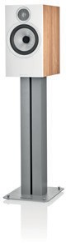
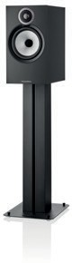
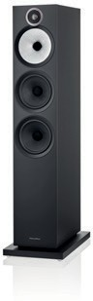
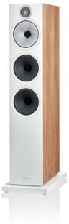
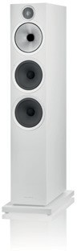

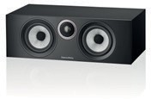
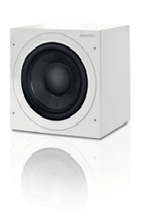
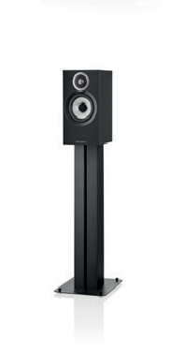
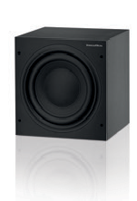

603 S3
$2500/pr.
A floorstanding speaker featuring an all-new 25mm (1”) Titanium Dome tweeter, a 150mm (6”) FST Continuum Cone midrange driver plus two 165mm (6.5”) paper- cone bass drivers.

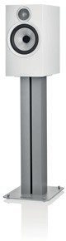

606 S3
$1100/pr.
A standmount or bookshelf speaker featuring the all- new 25mm (1”) Titanium Dome tweeter with a 165mm (6.5”) Continuum Cone mid/bass driver.

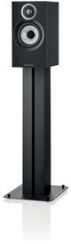
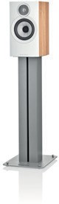
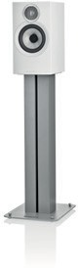

607 S3
$900/pr.
A compact standmount or bookshelf speaker featuring the all-new 25mm (1”) Titanium Dome tweeter and 130mm (5”) Continuum Cone mid/bass driver.

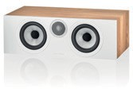
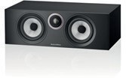
HTM6 S3
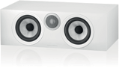
$900/ea.
A dedicated, high-performance centre-channel speaker featuring the all-new 25mm (1”) Titanium Dome tweeter plus dual 130mm (5”) Continuum Cone mid/bass drivers.

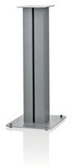
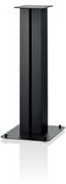
FS-600 S3 ﬂoor stand
$300 (per pair)
A mass–loadable stand suitable for use with both 607 S3 and 606 S3 available in black or silver and with top plate fixings for a direct connection to the speaker.

ASW608 and ASW610
$599 and $899 respectively
Two active subwoofers are available in matte black or matte white.

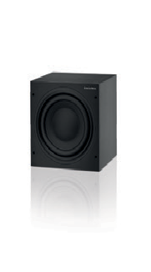

600 Series S3 Theatre
$5199
5.1 speaker Home Theatre package featuring 603 S3, 607 S3, HTM6 S3 plus the ASW610 active subwoofer

For more information, please contact:

Nicoll Public Relations
John Nicoll/Lucette Nicoll
john@nicollpr.com
lucette@nicollpr.com
1+781-789-6000

Digital Images can be
downloaded here on the Hub:

Copyright © B&W Group Ltd. E&OE.

About Bowers & Wilkins

Bowers & Wilkins, founded in the UK in 1966, has been at the forefront of high-performance audio for more than 50 years. Bowers & Wilkins designs and manufactures precision home speakers, headphones, custom installation and performance car audio products that set new standards for innovation and sound quality, earning countless awards and accolades from the world’s leading recording studios and musicians.
Bowers & Wilkins’ reputation is based on the unwavering pursuit of the best possible sound and an unsurpassable music listening experience. Learn more at bowerswilkins.com.

