THIS RELEASE IS UNDER EMBARGO UNTIL 03:00AM EST, 28TH JUNE 2023

Crafted. Honed. Perfected.
Bowers & Wilkins introduces the 800 Series Signature – the ultimate version of its acclaimed 800 Series Diamond loudspeaker range

- The new 801 D4 Signature further refines and advances the already reference-standard
801 D4, introducing all-new levels of insight and realism that truly put it in a class of its own
- The new range also introduces the 805 D4 Signature, designed to bring category-defining levels of transparency and accuracy to a more compact loudspeaker footprint, making it the perfect choice for discerning listeners in smaller spaces
- Both models feature no-holds-barred performance upgrades based on unique, proprietary Signature technologies not found in other 800 Series Diamond loudspeakers. Combined with exclusive new finishes and luxurious detailing, the two new Signature loudspeakers are a level above the best
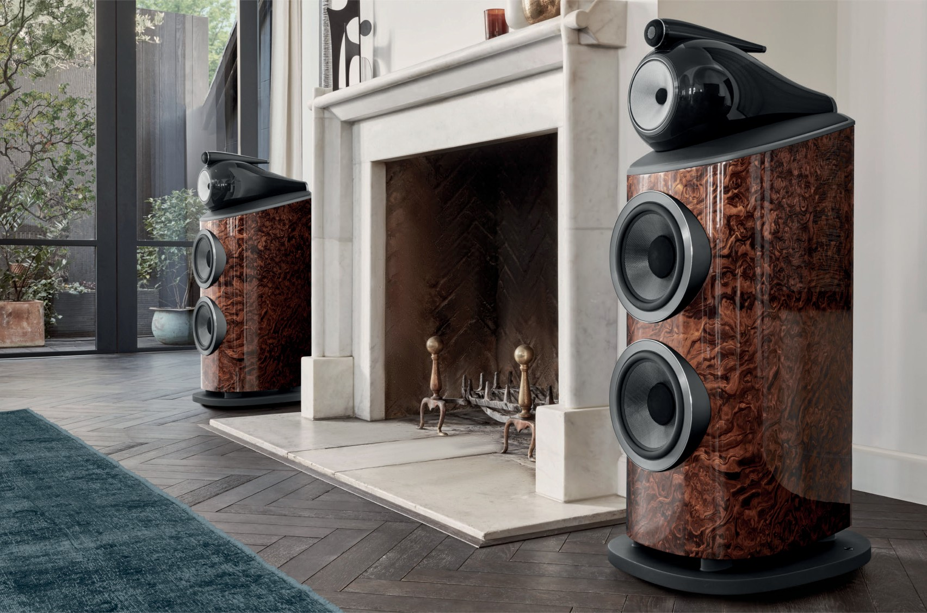

Worthing, UK, 28th June: Bowers & Wilkins only uses the Signature name sparingly, reserving it for the rare and radically upgraded versions of its conventional loudspeakers and technologies. Since the brand was founded in 1966, only seven series of loudspeaker have carried the prestigious Signature mark – a reflection of its prestige and exclusivity.

The new Bowers & Wilkins 801 D4 Signature and 805 D4 Signature build on a heritage that stretches back to the acclaimed Silver Signature loudspeaker of 1991, originally developed as a posthumous tribute to the founder of the company, John Bowers. The new models build on the already exceptional performance and aesthetic benchmarks of the 801 D4 and 805 D4 models that form the basis of their respective designs, featuring carefully upgraded componentry plus luxurious and beautiful new finishes.

The new 801 D4 Signature and 805 D4 Signature represent the pinnacle of current Bowers & Wilkins thinking and design and as such should be viewed as the new flagships in the company’s loudspeaker portfolio.

A new statement in floorstanding loudspeakers

The larger model in the new Signature range is the 801 D4 Signature, a powerful three-way floorstanding loudspeaker that builds on the specification of the iconic 801 D4 as found in Abbey Road Studios.
Based on the brand’s Diamond Dome tweeter and Continuum™ Cone FST™ midrange drive unit, the
801 D4 Signature adds powerful twin 250mm (10”) Aerofoil Cone bass drivers with upgraded and improved magnets to their motor systems relative to the 801 D4 model. It also includes a radically enhanced

aluminium top plate beneath its Turbine Head midrange enclosure; this new design uses a new optimised skeletal structure and carefully placed damping material to significantly reduce unwanted resonance from the top of the enclosure. The result is even more midrange transparency and openness to the already outstanding performance of the 801 D4.

The port output on 801 D4 Signature has received similarly significant upgrades; it is now cast from aluminium, creating a stiffer and quieter structure that is less prone to unwanted port noise. In combination with the updated Aerofoil Cone bass drivers, this results in even cleaner, lower distortion and more accurate sounding bass.

As with all Signature models over the years, the 801 D4 Signature benefits from careful upgrades to its crossover aimed at further increasing transparency with new and upgraded bypass capacitors for every element of the assembly. Finally, the 801 D4 Signature introduces a new FEA-optimised design of tweeter grille mesh that builds on the already impressive transparency offered by existing Bowers & Wilkins loudspeakers. The new mesh provides a new superior blend of transparency and stiffness, allowing
even more energy from the Diamond Dome tweeter into the room, while guarding the diaphragm against unwanted damage.

Our highest performance standmount ever

The 805 D4 Signature brings new standards of performance and capability in a smaller, more room-friendly form factor than its mighty sibling. As with the larger 801 D4 Signature model, the 805 D4 Signature also includes an all-new grille mesh for more openness and transparency plus an upgraded crossover with new bypass capacitors. In addition, an all-new bass / midrange motor system features upgraded performance from its 165mm (6.5”) drive unit, ensuring both a cleaner delivery through the midrange plus more extended bass. Finally, it features mechanical revisions to its aluminium top plate aimed at further reducing unwanted noise and vibration from the structure.

Exclusivity celebrated

To properly identify their prestigious position within the Bowers & Wilkins portfolio, both the 801 D4 Signature and 805 D4 Signature are only available in two exclusive new finishes. The Midnight Blue Metallic paint
is the same as offered on the iconic Nautilus loudspeaker, featuring a total of eleven coats of paint and lacquer that are machine polished to a gleaming and lustrous finish. Excluding curing times, the paint application process alone is in excess of 18 hours of labour. Midnight Blue Metallic loudspeakers are further celebrated with a bespoke blue Leather by Connolly trim on the top plate.

Alternatively, both models can be purchased in an exceptional California Burl Gloss wood veneer, featuring unique wood figuring and a luxurious high gloss finish trimmed in black Leather by Connolly. The wood veneer is sustainably sourced engineered wood from Italian specialist, ALPI. Including no less than fourteen coats of lacquer and multiple sanding processes, the total finishing time for a single 801 D4 Signature in California Burl Gloss is in excess of 24 hours.

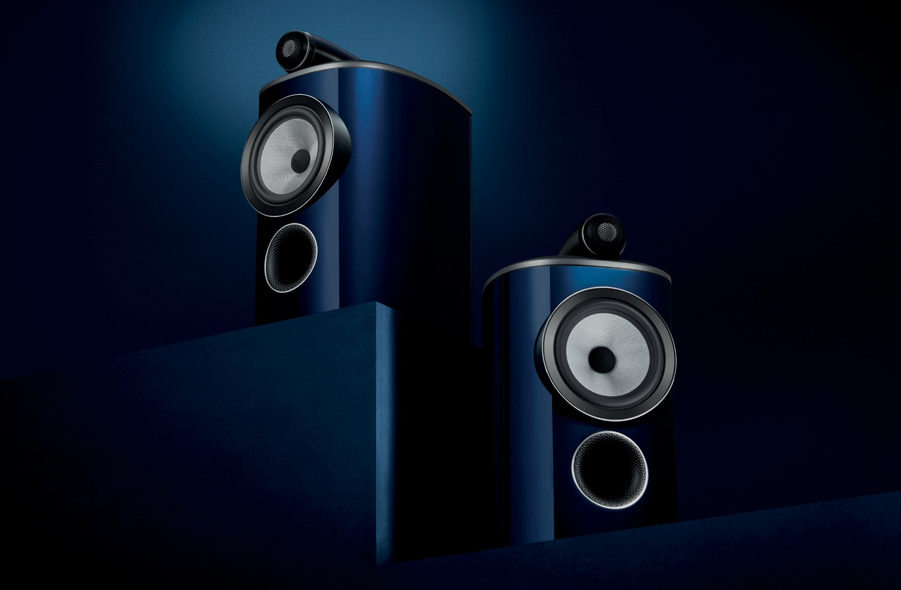

As with all Signature loudspeakers over the decades, both our new 800 Series Signature models are the perfect embodiment of Bowers & Wilkins’ product philosophy and are a proud addition to our heritage in this category. The company remains passionate about providing the best, truest listening experience we can. The 800 Series Signature models are the next step in the journey towards this goal.
This is the best of our best.

Commenting on the launch, Dave Sheen, Brand President of Bowers & Wilkins said: “800 Series Signature represents the coming together of everyone across the Bowers & Wilkins brand, from our colleagues in manufacturing to our world-class engineering teams in R&D, to produce the very best loudspeakers that we have ever made. I’m incredibly proud of the collective effort that has gone into producing the new 800 Series Signature models and I can’t wait to hear what both reviewers and our customers make of them.”

Available from 28th June from selected dealers, 800 Series Signature is available in two special finishes:
Midnight Blue Metallic and California Burl Gloss.

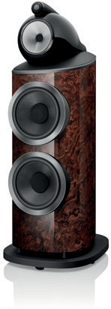
801 D4 Signature
$50,000 USD per pair

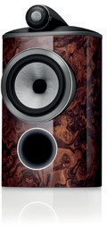
805 D4 Signature
$12,000 USD per pair

Notes to Editors

About Bowers & Wilkins
Bowers & Wilkins, founded in the U.K. in 1966, has been at the forefront of high-performance audio technology for more than 50 years. It designs and manufactures precision home speakers, headphones, custom installation and performance car audio products that set new standards for innovation and sound quality, earning countless awards and accolades from the world’s leading recording studios and musicians. Bowers & Wilkins’ reputation is based on the unwavering pursuit of the best possible sound and an unsurpassable music listening experience. Learn more at www.bowerswilkins.com.

For more information, please contact:

Nicoll Public Relations
John Nicoll/Lucette Nicoll
John@nicollpr.com
Lucette@nicollpr.com

1+781-789-6000

Photography and Assets
Download high-resolution images,
fact sheets, and press release
from the Bowers & Wilkins Hub here.

The content in this news release is accurate at the time of publication but may be subject to change without notice. All trademarks mentioned in this news release are the property of their respective owners. Copyright © B&W Group Ltd. E&OE

