THIS RELEASE IS UNDER EMBARGO UNTIL 08:00AM GMT, 10TH MAY 2023

Icon. Legend. Inspiration.
Nautilus – the world’s most iconic loudspeaker – celebrates 30th Anniversary
- Nautilus – the ultra-high-end loudspeaker like no other – has been hand-made to order at the Bowers & Wilkins factory in Worthing for 30 years

- To mark this milestone, Bowers & Wilkins has created a unique pair of Nautilus finished in a stunning Abalone Pearl paint, a dramatic finish that perfectly commemorates this landmark anniversary

- The unique Pearl-finished loudspeakers star in a new Bowers & Wilkins film that explores the story behind the birth of Nautilus, the craft and passion that goes into making each pair and the extraordinary impact its design has had on the world of audio
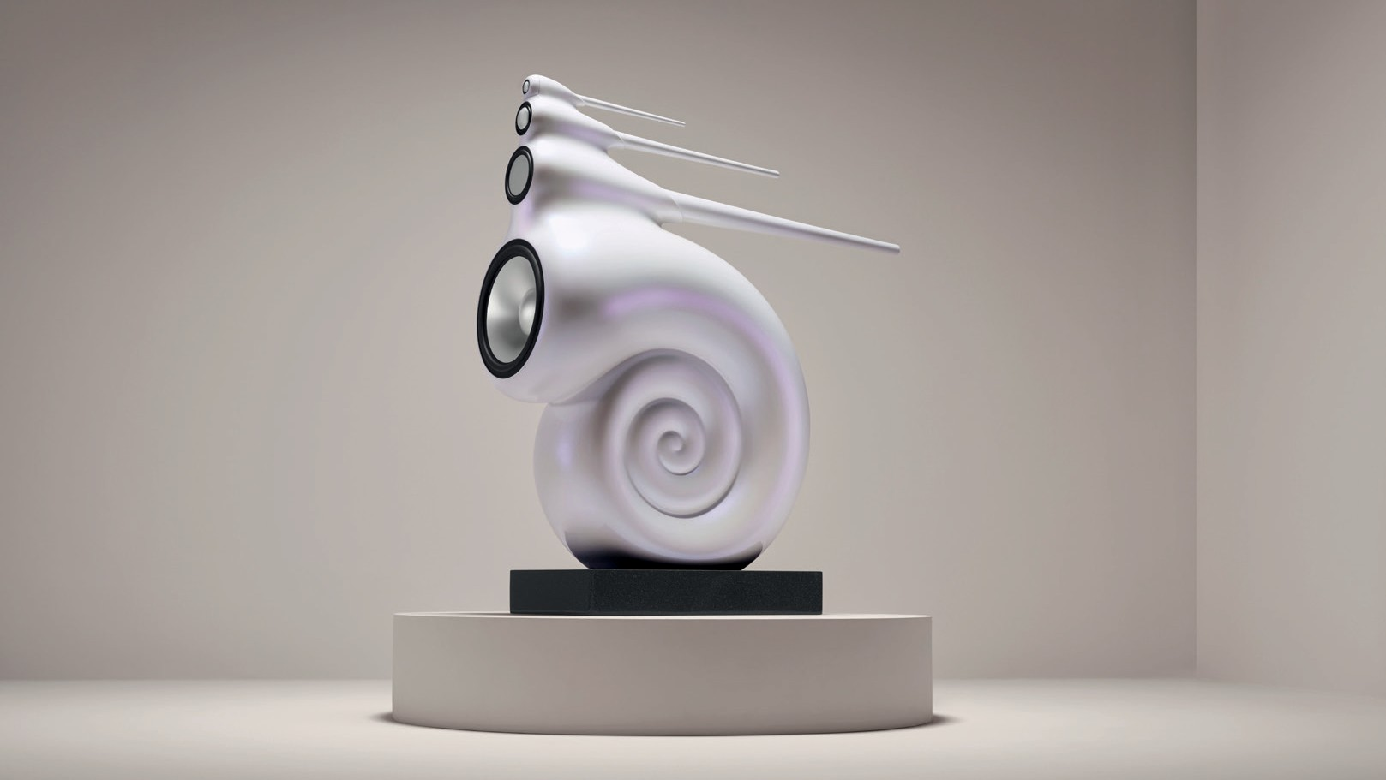

Worthing, UK, 10th May: Nautilus is and always has been a unique combination of unbridled ambition and revolutionary design – the result of truly original ‘outside the box’ thinking that perfectly encapsulates the Bowers & Wilkins brand philosophy.

To celebrate the 30th Anniversary of this iconic loudspeaker, Bowers & Wilkins has produced a unique pair in a dramatic Abalone Pearl finish. Pearl is, of course, the perfect colour for a 30th Anniversary – and it’s all-the-more appropriate since it’s also the colour of the internal shell of the marine mollusc that inspired the Nautilus name.

That Nautilus is still the most visually arresting speaker available, even some 30 years after its introduction, is testimony to the remarkable, ground-breaking vision of both company founder John Bowers, who initiated the Nautilus project shortly before he passed away, and the lead engineer who would eventually deliver on that legacy, Laurence Dickie.

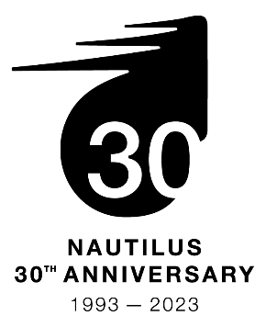
The idea behind Nautilus was simple, but immensely challenging: ‘make a loudspeaker that doesn’t sound like a loudspeaker’. Armed with an exceptionally wide brief, no time constraints and few limitations related to practicality or cost, the Nautilus emerged almost as a concept car made reality, a radical five-year project to explore how many of the negative effects of the loudspeaker enclosure could be eliminated by innovative design.

The result was a revolution in loudspeaker engineering that introduced the concept of the exponentially tapered tube to loudspeaker design. The Nautilus tube would go on to win a Queen’s Award for Innovation and was just one of many breakthroughs developed for the Nautilus project that would subsequently influence all of the company’s future product design. Alongside the equally remarkable 801, the choice of music industry professionals the world over, Nautilus was a key element in elevating Bowers & Wilkins into the world’s leading audio brand.

30 years later, Nautilus is still built the same way. Ironically for a company that has taken the manufacturing of audiophile speakers to new industry standards of automated precision, building a pair Nautilus is a painstaking hand-built process. Simply building one speaker enclosure takes over a week – and that’s before any notions of sanding, painting or polishing each cabinet are involved. Small wonder that demand for Nautilus has consistently outstripped supply throughout its 30-year existence, with the waiting list for a new model currently standing at two years.

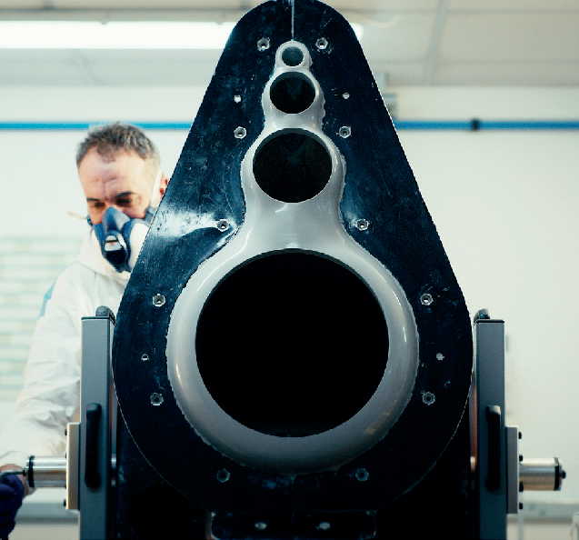
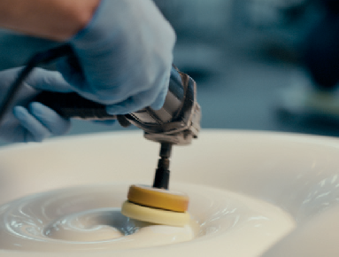
Nothing in audio looks or sounds like Nautilus, which remains an icon of radical thinking and revolutionary design to this day. The Abalone Pearl finish of the 30th Anniversary pair is a stunning celebration of one of the most legendary loudspeakers ever created.

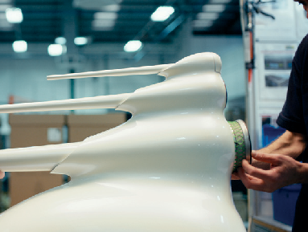

Commenting on the 30th Anniversary, Dave Sheen, Brand President of Bowers & Wilkins said:
“While Bowers & Wilkins is committed to advancing the future of high-performance audio across all of our product portfolio, Nautilus remains of the highest importance to all of us. It readily communicates everything that is exceptional about Bowers & Wilkins and our no-holds-barred approach to creating the world’s best-sounding, most beautifully designed audio products.”

Nautilus is available in three standard colours: Midnight Blue Metallic, Silver and Black. Bowers & Wilkins also offers a custom-finish service that will match the product’s colour to any reference the customer chooses at an extra cost.

Notes to Editors

About Bowers & Wilkins
Bowers & Wilkins, founded in the U.K. in 1966, has been at the forefront of high-performance audio technology for more than 50 years. It designs and manufactures precision home speakers, headphones, custom installation and performance car audio products that set new standards for innovation and sound quality, earning countless awards and accolades from the world’s leading recording studios and musicians. Bowers & Wilkins’ reputation is based on the unwavering pursuit of the best possible sound and an unsurpassable music listening experience. Learn more at www.bowerswilkins.com.

For more information, please contact:

Nicoll Public Relations
John or Lucette Nicoll
617-470-9906 / 781-789-6000
john@nicollpr.com
lucette@nicollpr.com

Download high-resolution images, fact sheets, and press release from the Masimo Consumer Hub. Copyright © B&W Group Ltd. E&OE.

