EMBARGOED UNTIL 26TH APRIL 2023 - 12NOON

Bowers & Wilkins is the diamond choice for BMW XM

Drawing on more than 50 years of expert design and craftsmanship, leading British audio manufacturer Bowers & Wilkins is once again bringing the developments from its world- renowned home audio to BMW Group, with the launch of the BMW XM.
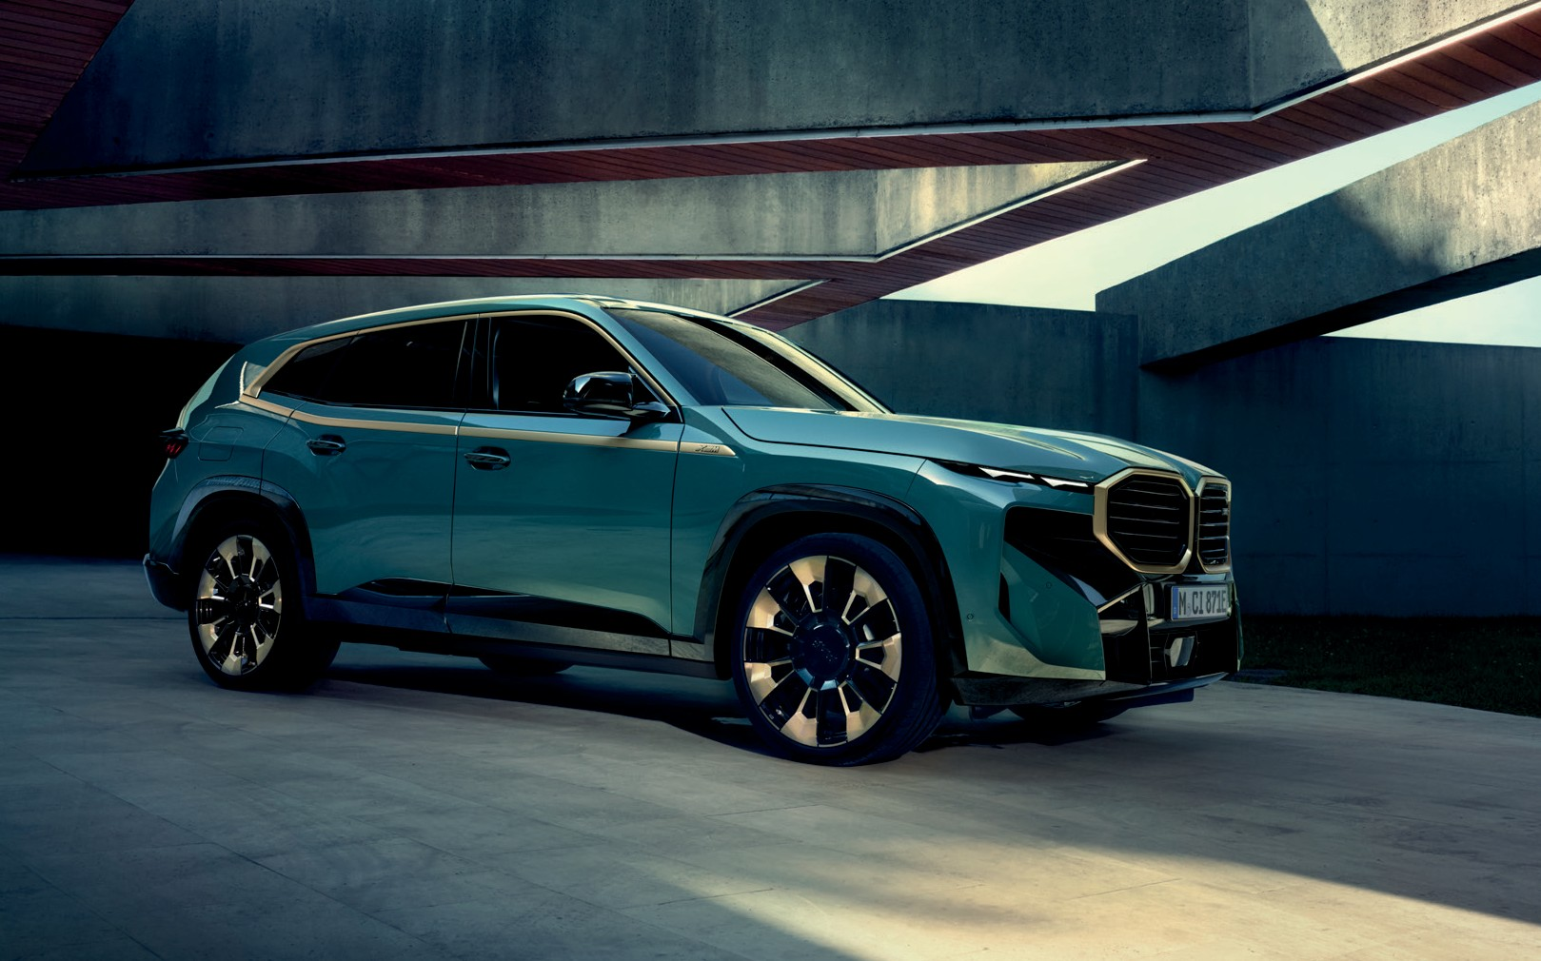

The Diamond Surround Sound System by Bowers & Wilkins, which also featured in the launch of the new BMW 7 Series models, combines expert engineering and elegant design to deliver audio excellence throughout the vehicle’s interior.

Dan Shepherd, Vice President of Licensing and Partnerships at Bowers & Wilkins, said: “We are proud to be continuing our partnership with BMW Group to incorporate our high-performance Diamond Surround Sound System in the BMW XM.”

“BMW drivers expect only the best when choosing their vehicles, making the Diamond Surround Sound System in the all-new BMW XM the right choice for elevating their in-car audio experience.”

Inspired by Bowers & Wilkins’ flagship 800 Series Diamond loudspeakers, which are used in recording studios across the globe, most notably Abbey Road Studios in London, the vehicle’s sound system features 20 high-performance speakers to deliver high-fidelity audio for all occupants.

Bowers & Wilkins worked alongside designers and sound engineers from BMW Group from the very start of the vehicle’s development to bring its world-leading sound reproduction to the XM. Together,
the engineering teams ensure that speaker position around the vehicle is optimised for maximum performance, delivering an unparalleled in-car listening experience that is accurate and true to the original recording, a philosophy Bowers & Wilkins calls ‘True Sound’.

Key features of the Diamond Surround Sound System include five aluminium tweeters, two Rohacell central bass speakers under the front seats and two Diamond Dome tweeters in the driver and passenger side
A-pillars – bringing the same engineering and technology used in Bowers & Wilkins flagship home speakers to the vehicle.

The high-frequency Diamond Dome tweeters have been carefully cultivated under laboratory conditions using chemical vapour deposition and temperatures approaching that of the surface of the sun. These very light and extremely rigid tweeters push unwanted resonances far beyond what a human can hear.
As a result, the Diamond Dome tweeters create realistic treble, providing incredible accuracy with minimal distortion and delivering sound as it was intended to be heard. The car also features five Continuum™ midrange speakers in the front and rear doors, the dashboard and at the rear of the cabin to give an authentic recreation of music as the artist intended.

The XM is the second BMW vehicle to feature Continuum™ cones, born out of eight years of development and an enormous step forward in midrange speaker performance. The stainless-steel speaker grilles boast an exclusive pattern design that illuminates to help visually highlight the system’s outstanding sound quality.

Dan added: “Our continued partnership with BMW highlights Bowers & Wilkins’ position as the brand of choice for customers across a whole range of BMW vehicles, bringing our True Sound experience to more and more people around the world.”

For additional information on Bowers & Wilkins, please visit www.bowerswilkins.com.

Bowers & Wilkins
Bowers & Wilkins, founded in the U.K. in 1966, has been at the forefront of high-performance audio technology for more than 50 years. It designs and manufactures precision home speakers, headphones, custom installation and performance car audio products that set new standards for innovation and sound quality, earning countless awards and accolades from the world’s leading recording studios and musicians. Bowers & Wilkins’ reputation is based on the unwavering pursuit of the best possible sound and an unsurpassable music listening experience. Bowers & Wilkins joined the Sound United LLC family of brands in 2020. Learn more at www.bowerswilkins.com.

Useful links
Bowers & Wilkins - www.bowerswilkins.com Twitter - @BowersWilkins
Instagram - @bowerswilkins YouTube - /bowerswilkins Facebook - @BowersWilkins

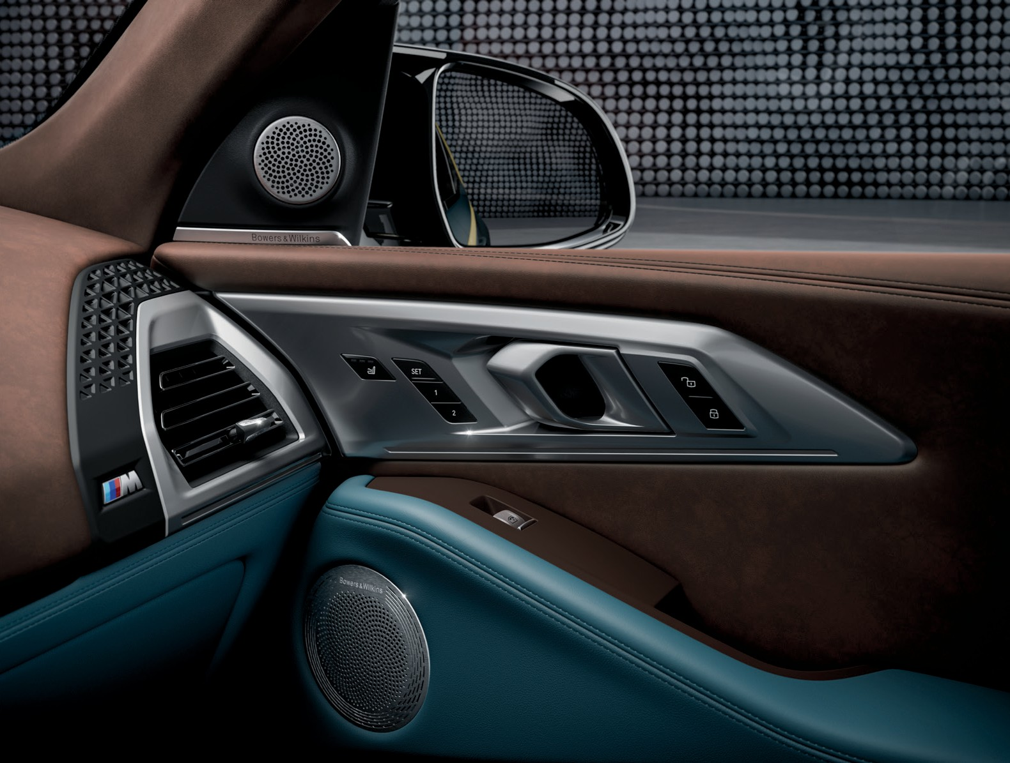
For more information, please contact:

Nicoll Public Relations
John Nicoll/Lucette Nicoll
John@nicollpr.com
Lucette@nicollpr.com

1+781-789-6000

Copyright © B&W Group Ltd. E&OE.

