Bowers & Wilkins introduces new Pi5 S2
Sage Green finish to join its premium in-ear
True Wireless headphone range
- Just in time for Spring, the Sage Green finish brings a fresh new look to the Pi5 S2 – joining the existing range of premium finishes: Cloud Grey, Storm Grey and Spring Lilac.
- Pi5 S2 continues to offer class-leading, Bowers & Wilkins sound at an affordable price, building on the award-winning status of the first-generation model.
- The new model features increased earbud battery performance, now offering five hours of listening time before a recharge is required.
- Enhanced wireless connectivity for stable, uninterrupted listening on the move, including a significant increase in Bluetooth range – now up to 25m.
- Bowers & Wilkins Music App seamlessly offers high-quality streaming from compatible streaming services, all in one place.
Worthing, England, 28th March: Bowers & Wilkins has launched a brand-new finish for its Pi5 S2 in-ear True Wireless headphones, which are now available in a fresh Sage Green hue, joining the existing premium finishes, including Cloud Grey, Storm Grey and Spring Lilac – the brand’s widest choice of headphone colours available to date.

Class-leading Bowers & Wilkins sound
The new Pi5 S2 offers the best audio performance in its class, with TWS transmission coupled to a single 9.2mm bespoke drive unit in each earbud. Pi5 S2 also offers seamless access to user-selectable noise cancellation plus an ambient pass-through mode, and it features twin built-in microphones per earbud for high-quality phone calls.
Pi5 S2 continues to offer premium design and materials plus upgrades to connectivity, extended earbud battery life, and a doubled Bluetooth range to up to 25m when compared to the first-generation models. A five-hour listening time is on offer before a recharge is required, with a quick charge function delivering an additional two hours’ listening time from just a 15-minute charge. The charging case provides an additional 19 hours of battery life.
Seamless user experience from the Music App
As with all new Bowers & Wilkins headphones, Pi5 S2 is fully integrated with the Bowers & Wilkins Music App. Offering a seamless user experience, complete with set-up, configuration of noise cancellation modes, and wear sensor adjustment, the Music App also supports high-quality streaming capability direct from your mobile device to your earbuds via services such as Qobuz, TIDAL and Deezer.
The new Pi5 S2 Sage Green in-ear True Wireless headphones are available now exclusively from bowerswilkins.com, priced at $299 USD.

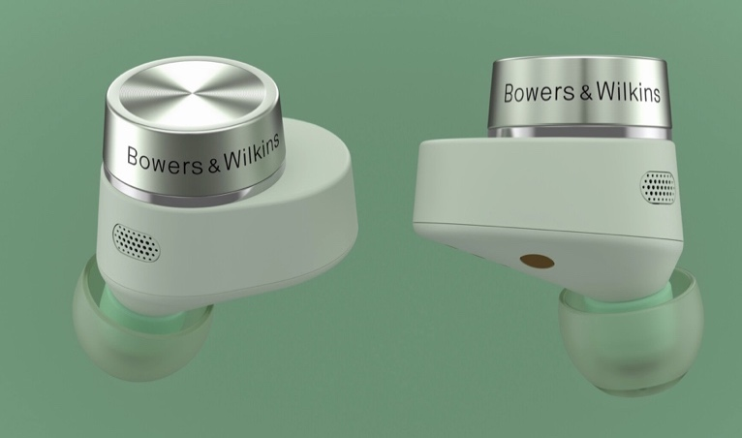
The Bowers & Wilkins Pi5 S2 is also available in Cloud Grey, Storm Grey and Spring Lilac.

About Bowers & Wilkins
Bowers & Wilkins, founded in the U.K. in 1966, has been at the forefront of high-performance audio technology for more than 50 years. It designs and manufactures precision home speakers, headphones, custom installation and performance car audio products that set new standards for innovation and sound quality, earning countless awards and accolades from the world’s leading recording studios and musicians. Bowers & Wilkins’ reputation is based on the unwavering pursuit of the best possible sound and an unsurpassable music listening experience.
For more information, please contact:
Nicoll Public Relations
John Nicoll/Lucette Nicoll
John@nicollpr.com
Lucette@nicollpr.com

1+781-789-6000

