Bowers & Wilkins speaker systems bring ‘True Sound’ to the new Lenovo™ Yoga™ 9i Gen 7 2-in-1 laptop
The new Lenovo Yoga 9i convertible (14”, Gen 7) will become the world’s first laptop to feature a bespoke Bowers & Wilkins sound system, specially designed to create a more authentic premium sound performance for portable computing.

Announced at CES®, the premium Lenovo Yoga 9i delivers an amazing audio experience with new enhanced speakers compared to the previous generation. The Lenovo Yoga 9i features an up to 4K OLED VESA® DisplayHDR™ 500 True Black, slim bezel touchscreen with 100 percent DCI-P3 color. Movies and music are heard as the artist intended with an improved Rotating Sound Bar now featuring Sound by Bowers & Wilkins.
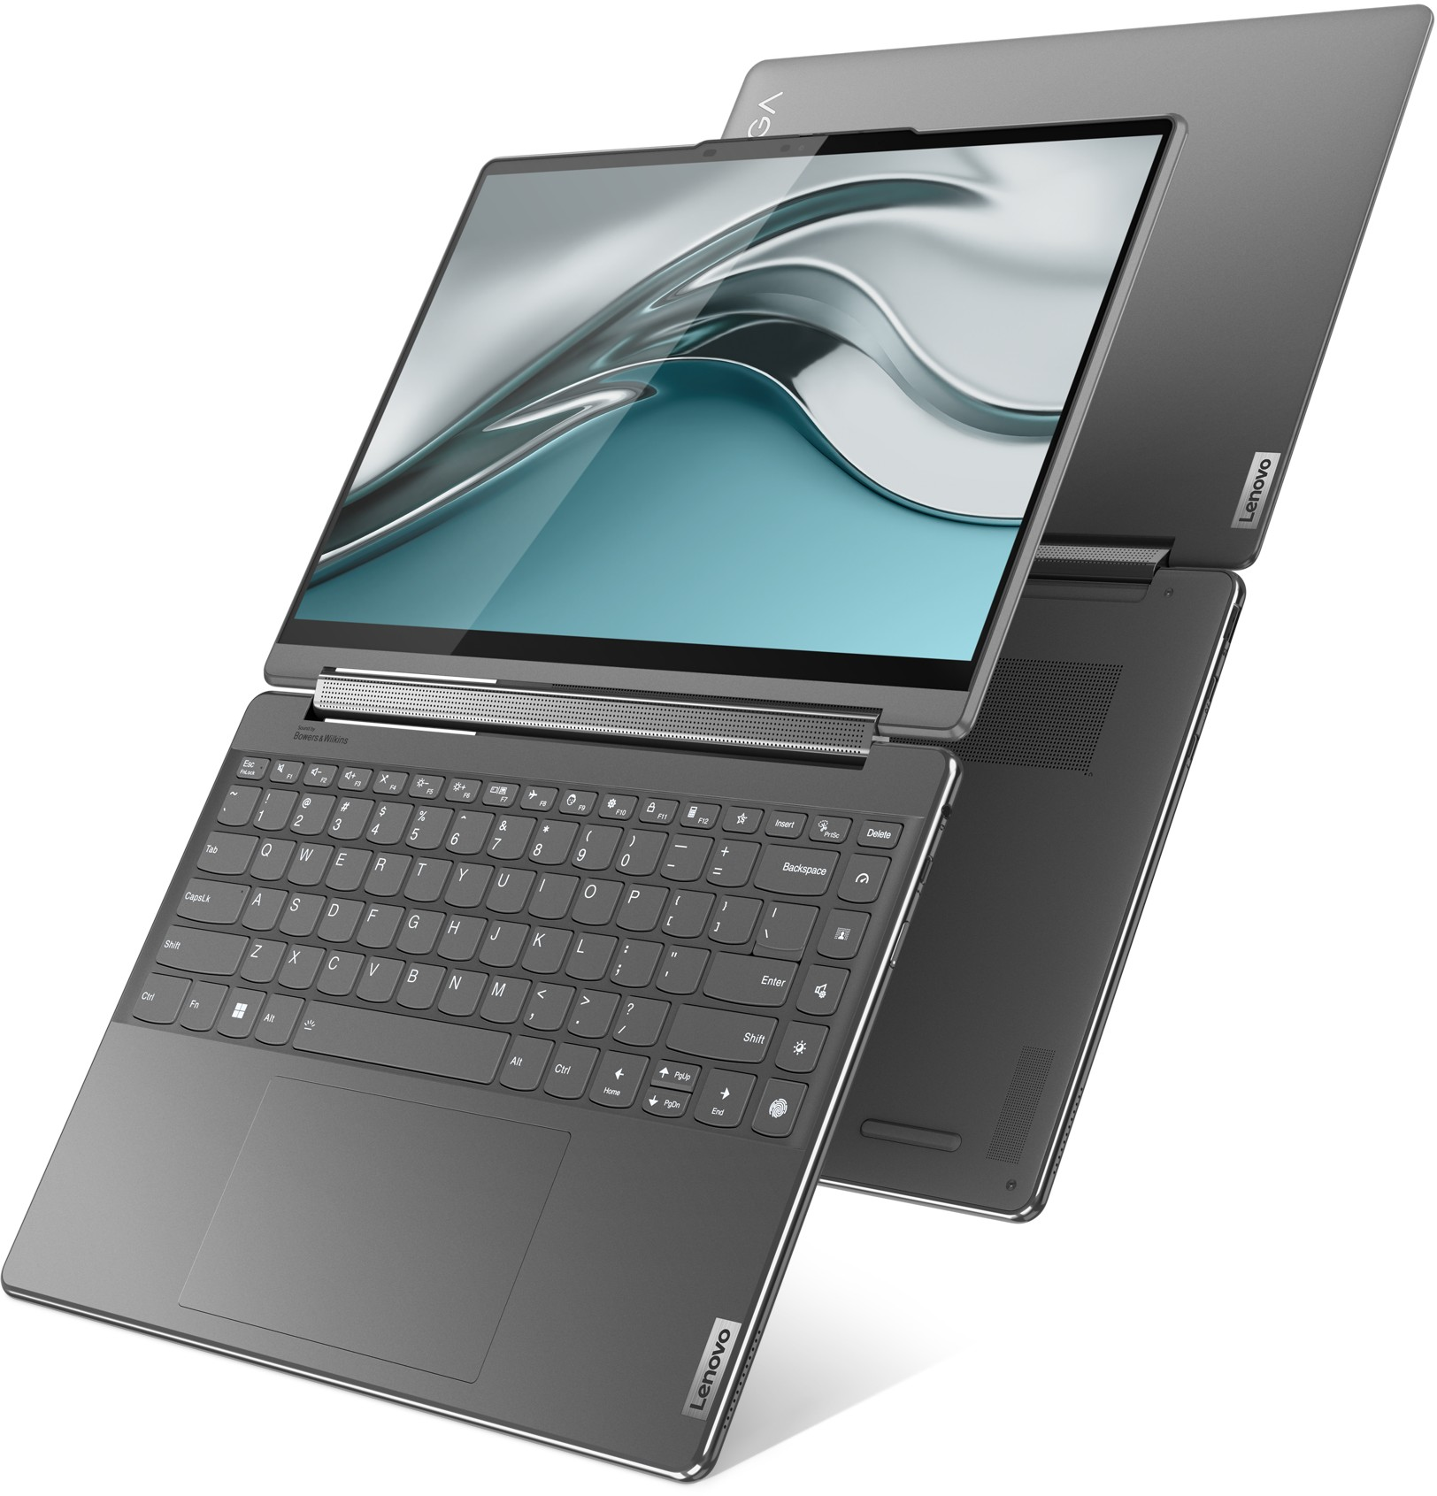
Bowers & Wilkins has engineered a four-speaker system – featuring bespoke high-quality drivers including two tweeters and two mid/bass woofers – into the thin body of the Lenovo Yoga 9i to offer extraordinary sound and bring a new sonic experience to movies, music or calls.

For over 50 years, Bowers & Wilkins has invented, designed and manufactured all of its core technologies in-house, leading the company to introduce a number of ground- breaking products, including the iconic 800 Series Diamond. Widely acknowledged to be the world’s best loudspeaker range, 800 Series Diamond speakers are the monitor of choice for the huge selection of iconic music and film scores that have been recorded and mixed at leading recording studios such as Abbey Road Studios and Skywalker Sound.
All of Bowers & Wilkins technologies are developed at the company’s R&D center in Southwater, England by the same engineering team for all projects, allowing the company to earn an outstanding reputation for consistently producing exceptional sound quality, irrespective of product type, size or form factor.

Two speakers for the Lenovo Yoga 9i sound system are seamlessly integrated into the product’s 360° rotating soundbar hinge and designed to always face towards the user, while two additional sideways-firing speakers are fitted along the edges of the product, for a total of four speakers and a more immersive and authentic audio experience.

By carefully designing the speaker enclosures and selecting the highest quality components while optimizing their position within the soundbar hinge, Bowers & Wilkins has produced a large scale, high resolution, low distortion and accurate sound that projects far beyond the enclosure and brings new realism to the on-screen content.

Commenting on the launch, Dave Sheen, SVP Licensing & Partnerships at Sound United said: “The team at Bowers & Wilkins is always excited to work with world-leading companies with a similar philosophy to our own. Like Lenovo, we think and act differently to redefine what is possible for performance in a different form factor. I’m delighted that we are collaborating with a company also focused on going beyond the conventional and intent on reshaping its markets.”

The Lenovo Yoga 9i convertible laptop (14”, Gen 7) is expected to be available globally in Q2 2022 and will start at $1,399.00.1

About Bowers & Wilkins
Bowers & Wilkins, founded in the U.K. in 1966, has been at the forefront of high-performance audio technology for more than 50 years. It designs and manufactures precision home speakers, headphones, custom installation and performance car audio products that set new standards for innovation and sound quality, earning countless awards and accolades from the world’s leading recording studios and musicians. Bowers & Wilkins’ reputation is based on the unwavering pursuit of the best possible sound and an unsurpassable music listening experience. Bowers & Wilkins joined the Sound United LLC family of brands in 2020. Learn more at www.bowerswilkins.com.
Visit Lenovo’s StoryHub newsroom for more information on the new Yoga 9i (14”, Gen 7).

1 Prices may not include tax and do not include shipping or options and are subject to change without notice; additional terms and conditions apply. Reseller prices may vary. On-shelf dates and color options may vary by geography and products may only be available in selected markets. All offers subject to availability. Lenovo reserves the right to alter product offerings, features and specifications at any time without notice.

LENOVO and YOGA are trademarks of Lenovo. CES is a trademark of the Consumer Technology Association. VESA and DISPLAYHDR are trademarks of the Video Electronics Standards Association.

For more information please contact:

Nicoll Public Relations
John or Lucette Nicoll
617-470-9906 / 781-789-6000 john@nicollpr.com Lucette@nicollpr.com

The content in this news release is accurate at the time of publication but may be subject to change without notice. All trademarks mentioned in this news release are the property of their respective owners. Copyright © B&W Group Ltd. E&OE

