Embargoed till 2/12/21 8:00 a.m. EST

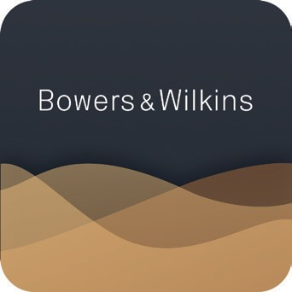

For more information, please contact:
Nicoll Public Relations
Lucette Nicoll or John Nicoll
Lucette@nicollpr.com
781-789-6000
John@nicollpr.com
617-470-9906

Download images from the
Bowers & Wilkins Hub here.

Get the app: iOS | Android

AirPlay is a trademark of Apple Inc., registered in the U.S. and other countries. IOS is a trademark or registered trademark of Cisco in the U.S. and other countries and is used under license. The Bluetooth® word mark and logos are registered trademarks owned by Bluetooth SIG,Inc. and any use of such marks by Bowers & Wilkins is under license. Other trademarks and trade names are those of their respective owners. Qualcomm is a trademark of Qualcomm Incorporated, registered in the United States and other countries. aptX is a trademark of Qualcomm Technologies International, Ltd., registered in the United States and other countries.

Bowers & Wilkins Announces Significant

Upgrade to its Formation-enabled Products.

New Music App Offers a Wider Range of Music-streaming Services and Enhanced Usability, with More Upgrades to Follow.

WORTHING, UK (February 12, 2021)—Bowers & Wilkins, the leading global premium audio brand, is proud to announce an exciting new development to its Formation wireless technology platform.

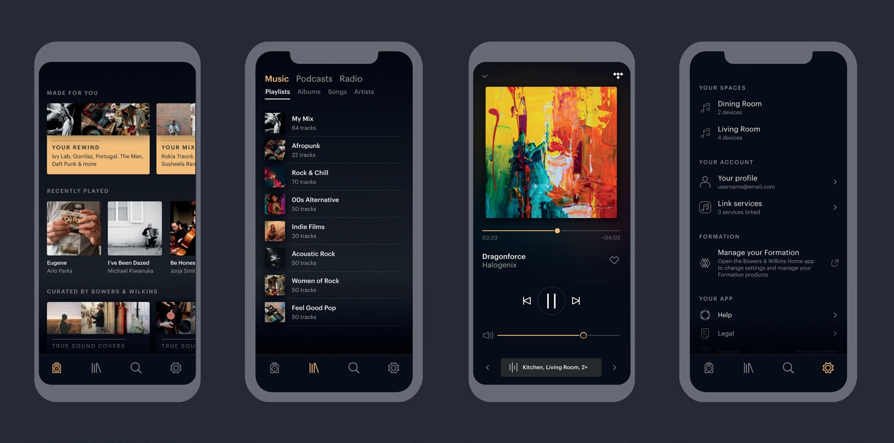

Launching on February 12th, the new Bowers & Wilkins Music App significantly increases the number of music-streaming services accessible to owners of Formation-enabled Bowers & Wilkins products. Available to both Android™ and iOS users, the App will initially offer support for Qobuz, TIDAL, TuneIn, Dash Radio, NTS Radio and SoundCloud, with more subscription services and streaming platforms to be added in the coming months. High-resolution (24-bit/96kHz) performance is also available, via Qobuz.

The Bowers & Wilkins Music App aggregates content from each available music service into one easily browsed and elegant interface to access tracks, albums, playlists and radio stations. Personalized recommendation features and a selection of curated Bowers & Wilkins playlists further enhance the user experience by simplifying and enhancing their daily listening choices.

Initially, the Bowers & Wilkins Music App will operate alongside the existing Bowers & Wilkins Home App, which will continue to provide set-up functionality for Formation-enabled products in the short term. Later in the year, Bowers & Wilkins will combine all App functionality for Formation-enabled products into the Music App to create a unified set-up, control and streaming experience, at which point the existing Home App
will lapse.

All other functionality already offered by Formation-enabled products remains current, including AirPlay® 2 and Bluetooth® aptX™ HD support for streaming from mobile devices, integrated support for both Spotify Connect and Roon, plus “Works With Alexa” certification.

The Formation platform is wholly owned by Bowers & Wilkins. The company recently expanded its development resources and engineering team with significant recruitment aimed at expanding its software and user experience skillsets. Going forward, Bowers & Wilkins plans to continue to invest in and expand the capabilities of its Formation-enabled product portfolio to both further improve the user experience and to add new features, including support for popular custom-installation control systems such as Control4.

Commenting on the news, Bowers & Wilkins Brand President Geoff Edwards said, “I’m delighted to announce this significant extension in the scope and capability of our class-leading Formation technology. The new Music App is a statement of our intent to further develop and improve our Formation-enabled product portfolio and I’m certain it will help us continue to set the gold standard for wireless speaker sound quality going forwards.”

About Bowers & Wilkins
Bowers & Wilkins, founded in the UK in 1966, has been at the forefront of high-performance audio for more than 50 years. Bowers & Wilkins designs and manufactures precision home speakers, headphones, custom installation and performance car audio products that set new standards for innovation and sound quality, earning countless awards and accolades from the world’s leading recording studios and musicians. Bowers & Wilkins’ reputation is based on the unwavering pursuit of the best possible sound and an unsurpassable music listening experience. Learn more at bowerswilkins.com.

