EMBARGOED UNTIL 21ST APRIL 2021

True Wireless. Incredible Sound.

Bowers & Wilkins reveals the PI7 and PI5 True Wireless headphones, engineered for incredible sound anywhere.

- British premium audio specialist launches two state-of-the-art True Wireless In-ear headphones, engineered for a high-performance audio experience wherever life takes you.

- PI7 and PI5 True Wireless headphones feature the unrivalled high-resolution sound quality that audiophiles and music lovers have come to expect from Bowers & Wilkins.

- Featuring industry-leading sound quality, immersive Adaptive Noise Cancellation, intuitive Wireless Audio Transmission, and wireless charging to benefit an on-the-go lifestyle.

- Developed by the same team behind the Bowers & Wilkins 800 Series Diamond loudspeakers found in Abbey Road Studios.

- Both PI7 and PI5 are available from 21st April 2021.

Worthing, England, April 2021: Today, British audio brand Bowers & Wilkins has unveiled two new state- of-the-art True Wireless headphones – PI7 and PI5 – that bring the brand’s acclaimed ‘True Sound’ promise and acoustic excellence to the True Wireless category.
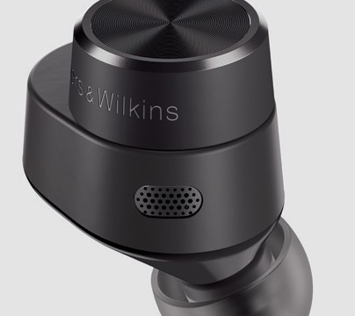

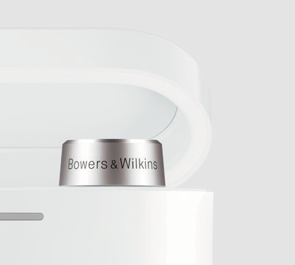
Both PI7 and PI5 models deliver the unrivalled high-resolution sound quality that audiophiles and music lovers have come to expect from Bowers & Wilkins. Now, that same signature sound quality is offered for the first time in True Wireless form, incorporating innovative and intuitive smart features designed to fit seamlessly into an on-the-go lifestyle.

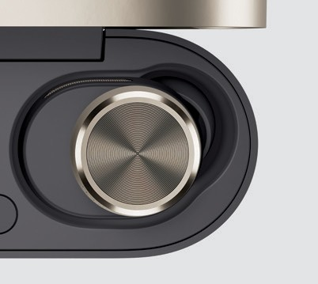
Drawing on over fifty years of industry-leading audio excellence and innovation, Bowers & Wilkins reveals another best-in-class portfolio of products that deliver your favourite music the way it is meant to be heard – as the artist intended it.

PI7 – The new industry-defining True Wireless headphones from Bowers & Wilkins.
Every element of the flagship PI7 model has been crafted to deliver the very highest level of audio performance, redefining expectation in True Wireless. PI7 features unrivalled sound quality, driven by
high-resolution 24-bit audio processing in each earbud and Dual Hybrid Drive units that work just like high- performance speakers to create a rich and immersive listening experience.

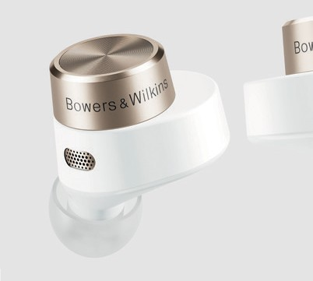
In addition, PI7 features Adaptive Noise Cancellation that automatically adapts in real-time to its surroundings to produce the best possible listening experience – so you can block out the world and focus on the music you love. It’s driven by six microphones – three in each earbud – for crystal-clear sound quality with every call, all activated though an intuitive, one-touch user interface.

Even the Smartcase is designed for an intuitive and seamless user experience. As you would expect, it can conveniently charge your device wirelessly while you are on-the-go. But, and in an industry first, PI7 raises the bar by offering a unique wireless audio retransmission feature via its Smartcase. That means you can continue to use your PI7s even when on a plane: just connect your case directly to an audio source – such as an in-flight entertainment system – and it will retransmit sound directly to your earbuds.

PI5 – The class-leading, Bowers & Wilkins True Wireless sound that’s with you all day.
PI5 is the class-leading True Wireless headphone with all of the high quality, audio-enhancing features expected from a Bowers & Wilkins product – the perfect accompaniment to an on-the-go lifestyle.

Alongside the exceptional audio performance and call quality, the PI5 offers over 24 hours of battery life, ensuring you stay connected throughout the day. This is accompanied by advanced Active Noise Cancellation, allowing you to easily adapt to your listening environment, whether you’re working from home or on a busy street, and a fast-charging case that provides a boost of up to two hours of battery life from just a 15-minute charge.

Bold design and Smart technology.
Both models embody the Bowers & Wilkins bold design to stand out from the crowd, with accents of color to highlight the beautifully precise detailing.

Smart technology makes living with PI7 and PI5 more convenient. Both models can be configured via the Bowers & Wilkins companion App and feature a simple one-button user interface, coupled with voice assistant support via either Siri or Google Assistant. Multiple source devices can be wirelessly paired to either model allowing the user to easily and conveniently reconnect to each source as and when needed.

Developed by the same team behind the Bowers & Wilkins 800 Series Diamond loudspeakers found in Abbey Road Studios, PI7 and PI5 both embody the same industry-leading engineering and design philosophy that has led to the creation of some of the world’s finest audio products.

Geoff Edwards, Brand President, Bowers & Wilkins, said: “We are excited to be venturing into the True Wireless category with our new headphones. It’s long been our philosophy, established by our founder John Bowers, that we would only enter a new category if we believed that we could set a new standard for audio performance in that space. With PI7 and PI5, we truly believe we have achieved that.”

The PI7 True Wireless and PI5 True Wireless headphones are available from www.bowerswilkins.com on April 21st 2021 for $399 and $249 respectively.

PI7
Available in White and Charcoal
$399 USD
PI5
Available in White and Charcoal
$249 USD

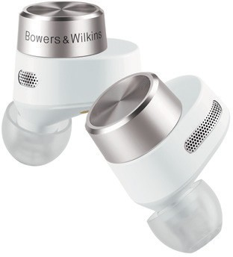
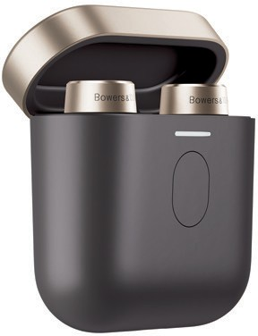
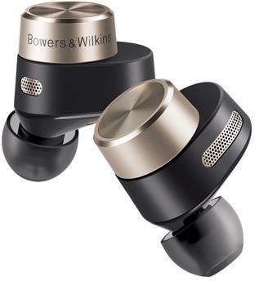
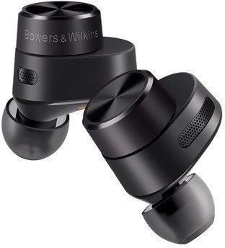

Notes to Editors:

PI7 Key Features

- True 24-bit audio connection gives superior audio quality so you can listen to your favourite music and movies the way they are meant to be heard.

- Strong Qualcomm® aptX™ Adaptive wireless transmission finds the best possible connection between your earbuds and listening device.

- Dual Hybrid Drive headphone units work just like high-performance speakers to create rich and immersive sound.

- Quad amps and advanced DSP ensure exceptional control, superlative dynamics and deep, accurate bass.

- Wireless charging case comes with a Quick Charge function that gives you another 2 hours of battery life after just 15-minutes of charge time, compatible with any wireless charging pad.

- The 6-Mic Array ensures each high-performance earbud benefits from three separate microphones that guarantees that your calls are always crystal clear.

- Audio Retransmission Case is an industry-first Smartcase that doubles as a unique retransmission system for in-flight entertainment or some gaming systems.

- Adaptive Noise Cancellation that automatically adjusts to your environment.

- Available in Charcoal and White colors.

PI5 Key Features

- TWS+ technology for high-quality earbud-to-earbud synchronization.

- Qualcomm aptX audio supports wireless transmission for high quality audio playback.

- Advanced Active Noise Cancellation.

- Two built-in microphones for high quality calls.

- Wireless charging case and Quick Charge support with 24-hours+ of battery life, with a Quick Charge function that gives you another 2 hours of battery-life after just 15-minutes of charge time, compatible with any wireless charging pad.

- Available in Charcoal and White colors.

About Bowers & Wilkins
Bowers & Wilkins, founded in the U.K. in 1966, has been at the forefront of high-performance audio technology for more than 50 years. It designs and manufactures precision home speakers, headphones, custom installation and performance car audio products that set new standards for innovation and sound quality, earning countless awards and accolades from the world’s leading recording studios and musicians. Bowers & Wilkins’ reputation is based on the unwavering pursuit of the best possible sound and an unsurpassable music listening experience. Bowers & Wilkins joined the Sound United LLC family of brands in 2020. Learn more at www.bowerswilkins.com.

For more information, please contact:

Nicoll Public Relations
John or Lucette Nicoll
617-470-9906 / 781-789-6000
John@nicollpr.com
Lucette@nicollpr.com
Download high-resolution images, fact sheets, and press release from the Bowers & Wilkins Hub.
https://hub.bowerswilkins.com/share/72D23457-44AD-42CE-BE629091DFA7A1EA/

Qualcomm aptX is a product of Qualcomm Technologies, Inc. and/ or its subsidiaries. Qualcomm is a trademark of Qualcomm Incorporated, registered in the United States and other countries. aptX is a trademark of Qualcomm Incorporated, registered in the United States and other countries. Copyright © B&W Group Ltd. E&OE.

