THIS INFORMATION IS EMBARGOED UNTIL 3:00 AM EST NOVEMBER 17TH 2021

705 and 702 Signature add stunning new Midnight Blue Metallic finish
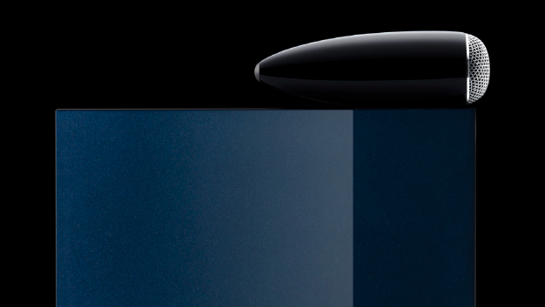

Worthing, England, 17th Nov 2021: Bowers & Wilkins has launched two new versions of its 705 Signature stand-mount and 702 Signature floor-standing loudspeakers. Available in stunning Midnight Blue Metallic paint, the 705 Signature and 702 Signature models feature the same class-leading combination of exceptional drive unit design and carefully upgraded crossover componentry as the existing Datuk Gloss-finished 700 Series Signature models, which remain available to purchase.

As befits such prestigious products, the new 705 & 702 Signature feature state-of-the-art Bowers & Wilkins technologies, including a decoupled Continuum cone midrange drive unit on the 702 Signature, complemented by Aerofoil-profile bass drivers. Both 702 and 705 Signature also feature the outstanding Carbon Dome tweeter, housed in Bowers & Wilkins iconic Solid Body Tweeter-on-Top assembly.

As with the existing Signature models, both Midnight Blue Metallic loudspeakers feature specially treated and upgraded bypass capacitors sourced from Mundorf, larger heatsinking and, in the case of the 702, an upgraded LF capacitor on the bass section of the crossover. In tandem with the immense benefits both models enjoy as a result of their Tweeter-on-Top configuration, these upgrades improve the already remarkable resolution, openness and spatial retrieval on offer, lending them an even-more polished, refined and involving sound.

Exceptional engineering on-board

Inspired by the Nautilus
As with the Datuk Gloss Signature models, the new Midnight Metallic Blue 702 and 705 Signature are finished to sumptuous standards. Inspired by the Midnight Metallic Blue paint offered on the iconic Bowers & Wilkins Nautilus, the new 702 and 705 Signature are finished in seven coats of metallic-finish paint and lacquer to produce a rich, lustrous finish. To further accentuate and highlight the quality of finish on each model, both Signature speakers have bright metal trim rings around the mid/bass and midrange cones plus bright, silver-finished tweeter grilles. Finally, both models have a Signature identity plate to their rear panel, turning each speaker into a genuine and unique piece of art.

Carbon Dome Tweeter
Both 700 Series Signature models feature Bowers & Wilkins Carbon Dome tweeter technology. Designed to bridge the performance gap between the Aluminium Double Dome used in the 600 Series and the Diamond Dome used in the 800 Series Diamond, the Carbon Dome is composed of two sections. The
front portion is a 30-micron aluminium dome that has been stiffened by a PVD (Physical Vapour Deposition) coating of carbon. The second section is a 300-micron carbon ring that has been profiled to match the form of the main dome. This is then bonded to the inner face of the structure. The outcome is exceptional stiffness and resistance to distortion without undue mass and a first break-up point of 47kHz.

Solid Body Tweeters
As with all preceding Signature products, the 705 Signature and 702 Signature are Tweeter-On-Top designs featuring, in this case, Solid Body Tweeter technology. This design is derived entirely from the approach used in the 800 Series Diamond and has the same performance benefits. As with the 700 Series
speakers, instead of using a hollow zinc housing, the new Signature models use the same shape milled from a solid mass of aluminium to provide a stiffer and less resonant structure. Weighing over 1kg, it is exceptionally inert, and benefits from the same decoupling mechanism and acoustically transparent grille design as the 800 Series Diamond. This design also allows the use of the mass of the tweeter body as a heatsink for the dome.
Continuum cone
Continuum cone midrange drivers were first seen in the 800 Series Diamond. The Continuum cone’s design is based on the concept of optimised and controlled flexibility. This helps the cone to avoid the abrupt transition from pistonic to break-up mode behaviour that drastically impairs the openness and neutrality of a conventional drive unit. Continuum is a woven composite that gives highly controlled break-up, for a more transparent and detailed midrange.

Midrange chassis
702 Signature is equipped with a dedicated midrange FST drive unit using a FEA-optimised aluminium chassis with a very stiff form, decoupled from the cabinet and further enhanced with the addition of a tuned mass damper on the front face of the chassis. This dampens any remaining resonance in the structure, resulting in a cleaner midrange presentation.

Midrange decoupling
The midrange decoupling system simplifies the design used in the 800 Series Diamond for a significant improvement in midrange spaciousness across the board.

Aerofoil-profile bass cone
A new implementation of the Aerofoil cone used in the 800 Series Diamond is featured on the 702
Signature, using a composite structure of inner and outer skins filled with a lightweight core of EPS. The
result is a dramatic uplift in bass performance.
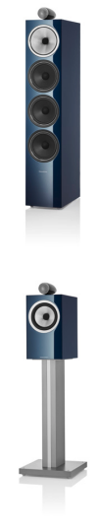

For more information, please contact:

Lucette Nicoll or
John Nicoll

Nicoll Public Relations
781-789-6000
617-470-9906
lucette@nicollpr.com
john@nicollpr.com

Download high-resolution images, fact sheets, and press release from the Bowers & Wilkins Hub

The content in this news release is accurate at the time of publication but may be subject to change without notice. Continuum, Carbon Dome and Aerofoil are trademarks of B&W Group Ltd. Mundorf is a trademark of Mundorf EB GmbH.

702 Signature
Available November/December 2021
$7,499 USD per pair

Floorstander
Three-way vented-box Tweeter-on-Top
3 x 6.5” Aerofoil Profile bass
1 x 6” Continuum FST midrange, decoupled
1 x 1” Carbon Dome tweeter in Solid Body Tweeter-on-Top

705 Signature
Available November/December 2021
$3,999 USD per pair

Stand-mount
2-way vented-box
Tweeter-on-Top
1 x 6.5” Continuum bass/midrange
1 x 1” Carbon Dome tweeter in Solid Body Tweeter-on-Top

About Bowers & Wilkins
Bowers & Wilkins, founded in the UK in 1966, has been at the forefront of high-performance audio for more than 50 years. Bowers & Wilkins designs and manufactures precision home speakers, headphones, custom installation and performance car audio products that set new standards for innovation and sound quality, earning countless awards and accolades from the world’s leading recording studios and musicians. Bowers & Wilkins’ reputation is based on the unwavering pursuit of the best possible sound and an unsurpassable music listening experience. Bowers & Wilkins joined the Sound United LLC family of brands in 2020. Learn more at bowerswilkins.com

