THIS INFORMATION IS CONFIDENTIAL UNTIL SEPTEMBER 16, 2020

Bowers & Wilkins launches special PX7 Carbon Edition wireless headphones to celebrate a decade of headphone success
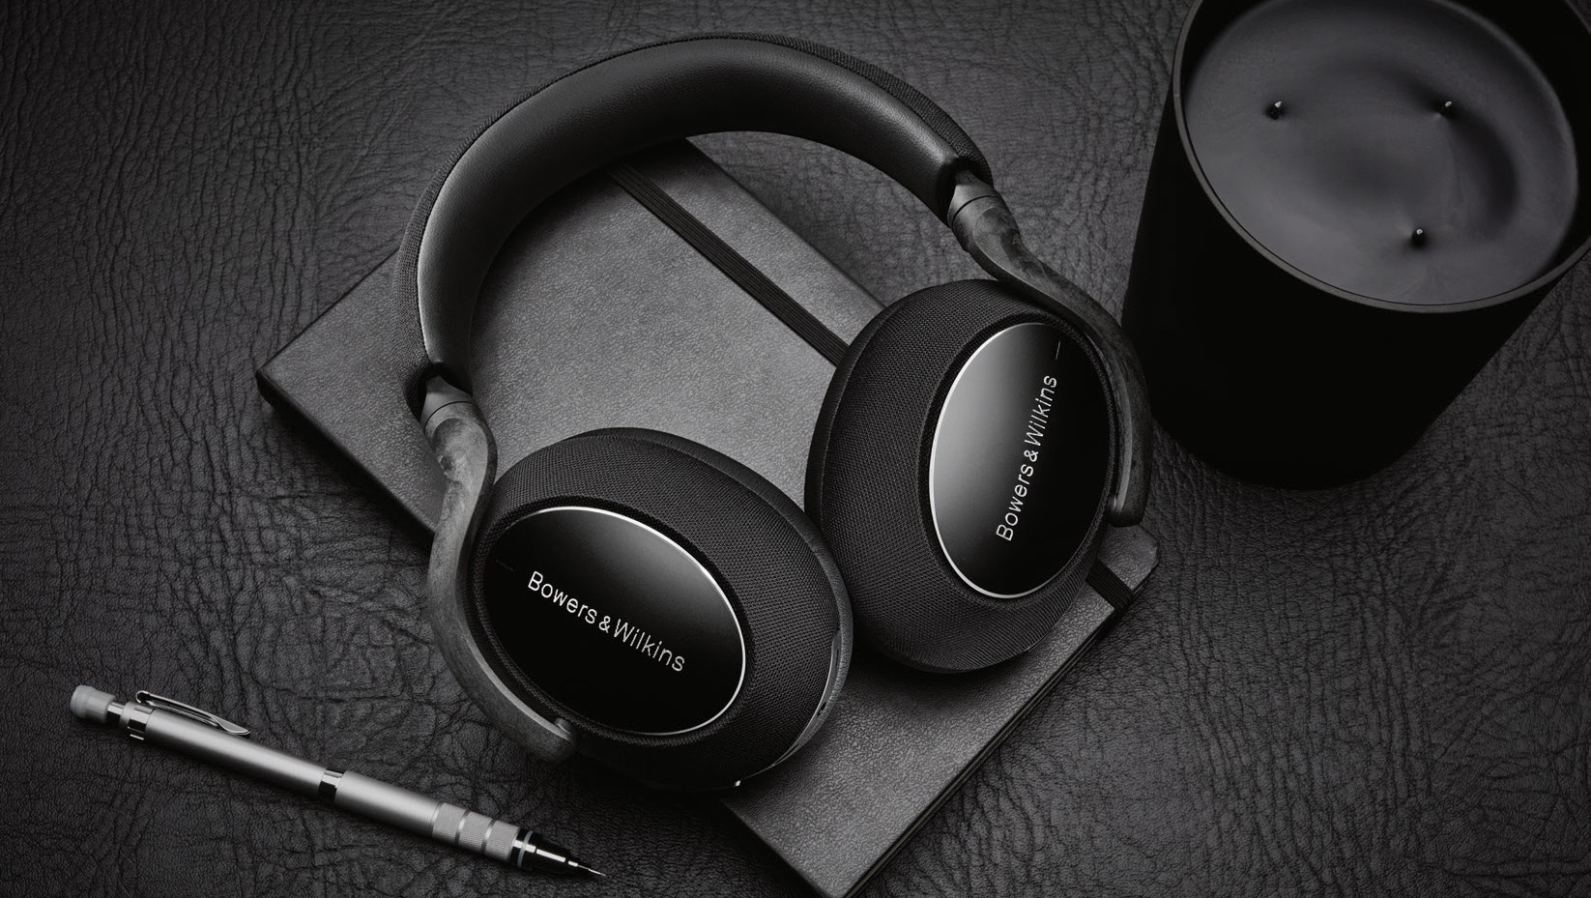
North Reading, MA – September 16, 2020: Over the past 12 months, Bowers & Wilkins has enjoyed outstanding success with its flagship PX7 over-ear wireless headphones. These adaptive noise-cancelling designs offer an unmatched combination of breathtaking sound quality, smart features and supreme comfort which together have helped them win countless awards and recommendations around the world.
2020 also marks the 10th anniversary of the launch of Bowers & Wilkins first-ever headphone design, the iconic P5—a breakthrough model that would swiftly redefine customer expectations for build, design and sound quality in the premium performance headphone category.

Now it’s time to celebrate that success, with the launch of the PX7 Carbon Edition. Designed to highlight the PX7’s pioneering use of carbon-fiber composite reinforcement in its construction, the new Carbon Edition features a high- quality carbon black finish with diamond-cut detailing on each ear cup, creating an even more premium look that also evokes the illustrious heritage of Bowers & Wilkins headphones over the years, inspired by the original P5.

Smart design, smart features.
The PX7 Carbon Edition shares the same proven specification as the existing PX7 models. First and foremost, it delivers True Sound, offering maximum resolution while maintaining complete neutrality and tonal balance. The aim is to recreate your favorite music exactly as the artist intended – whether with or without noise-cancelling selected. The PX7 Carbon Edition’s immersive soundstage is the result of a specification that includes bespoke 43.6mm drivers, specially designed, developed and tuned by the world-renowned Bowers & Wilkins engineering
team responsible for the legendary 800 Series Diamond loudspeakers – as used in such world-famous professional environments as Abbey Road Studios and Skywalker Sound.

To maintain sound quality, the PX7 Carbon Edition also supports the latest wireless codecs including the recently launched Bluetooth aptX Adaptive technology, allowing the transfer of genuine high-resolution music wirelessly at 24-bit/48kHz streaming quality.

Much engineering effort was also spent on the design of the headband and earcup-supporting arms used in the PX7 Carbon Edition’s construction; as with all PX7s, these are made from a carbon-fiber-reinforced polymer for an optimal combination of lightness and stiffness. Memory foam ear pads also ensure that the headset starts with market-leading passive noise isolation. As for active noise cancellation, PX7 Carbon Edition’s adaptive technology
is capable of intelligently sensing the background environment and automatically selecting the appropriate type and level of noise cancellation. Users can also use the companion App to select an Ambient-Pass-Through feature that allows certain external sounds to be heard without removing the headset.

The PX7 Carbon Edition isn’t just sophisticated, it’s intuitive to use. It features proximity sensors built into both ear cups, so your music is automatically paused when either ear cup is lifted and automatically resumes when placed back on your ear. At the same time, PX7 Carbon Edition also offers push-button access to Voice Assistant Support via either Siri or Google Assistant depending on the type of phone used.

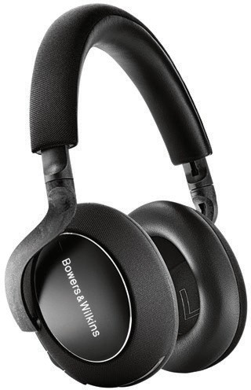

For more information, please contact:

Lucette or John Nicoll

Nicoll Public Relations
781-789-6000
617-470-9906
lucette@nicollpr.com
john@nicollpr.com

Download high resolution images, fact sheets and press release from the Bowers & Wilkins Hub here

The content in the news releases is accurate at the time of publication but may be subject to change without notice. All trademarks mentioned in this news release are the property of their respective owners. Copyright © B&W Group Ltd. E&OE

Finally, the PX7 Carbon Edition’s long battery life of up to 30 hours from a single charge (with ANC activated) is backed by a 15min quick-charge facility that will enable five more hours of use.

The comfortable, musical and beautiful PX7 Carbon Edition will be available in October, priced at USD $399.99. For more information about our wireless headphones, visit bowerswilkins.com.

About Bowers & Wilkins
Bowers & Wilkins, founded in the UK in 1966, has been at the forefront of high-performance audio for more than 50 years. Bowers & Wilkins designs and manufactures precision home speakers, headphones, custom
installation and performance car audio products that set new standards for innovation and sound quality, earning countless awards and accolades from the world’s leading recording studios and musicians. Bowers & Wilkins’ reputation is based on the unwavering pursuit of the best possible sound and an unsurpassable music listening experience. Learn more at bowerswilkins.com

